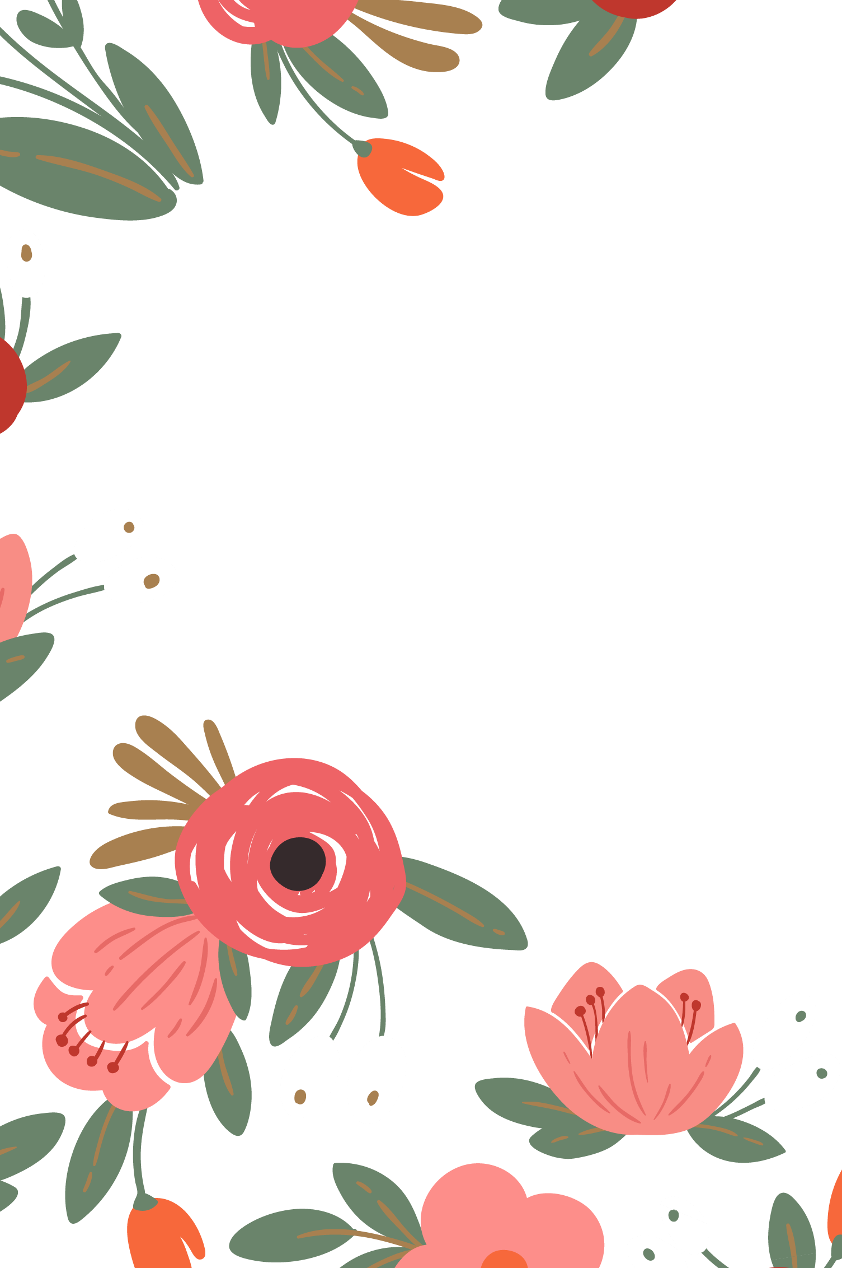

|  |  |
| --- | --- |
|  | 母亲节  **快乐** |

|  |  |
| --- | --- |
|  | 感谢您让这个家  成为最快乐的地方。 |

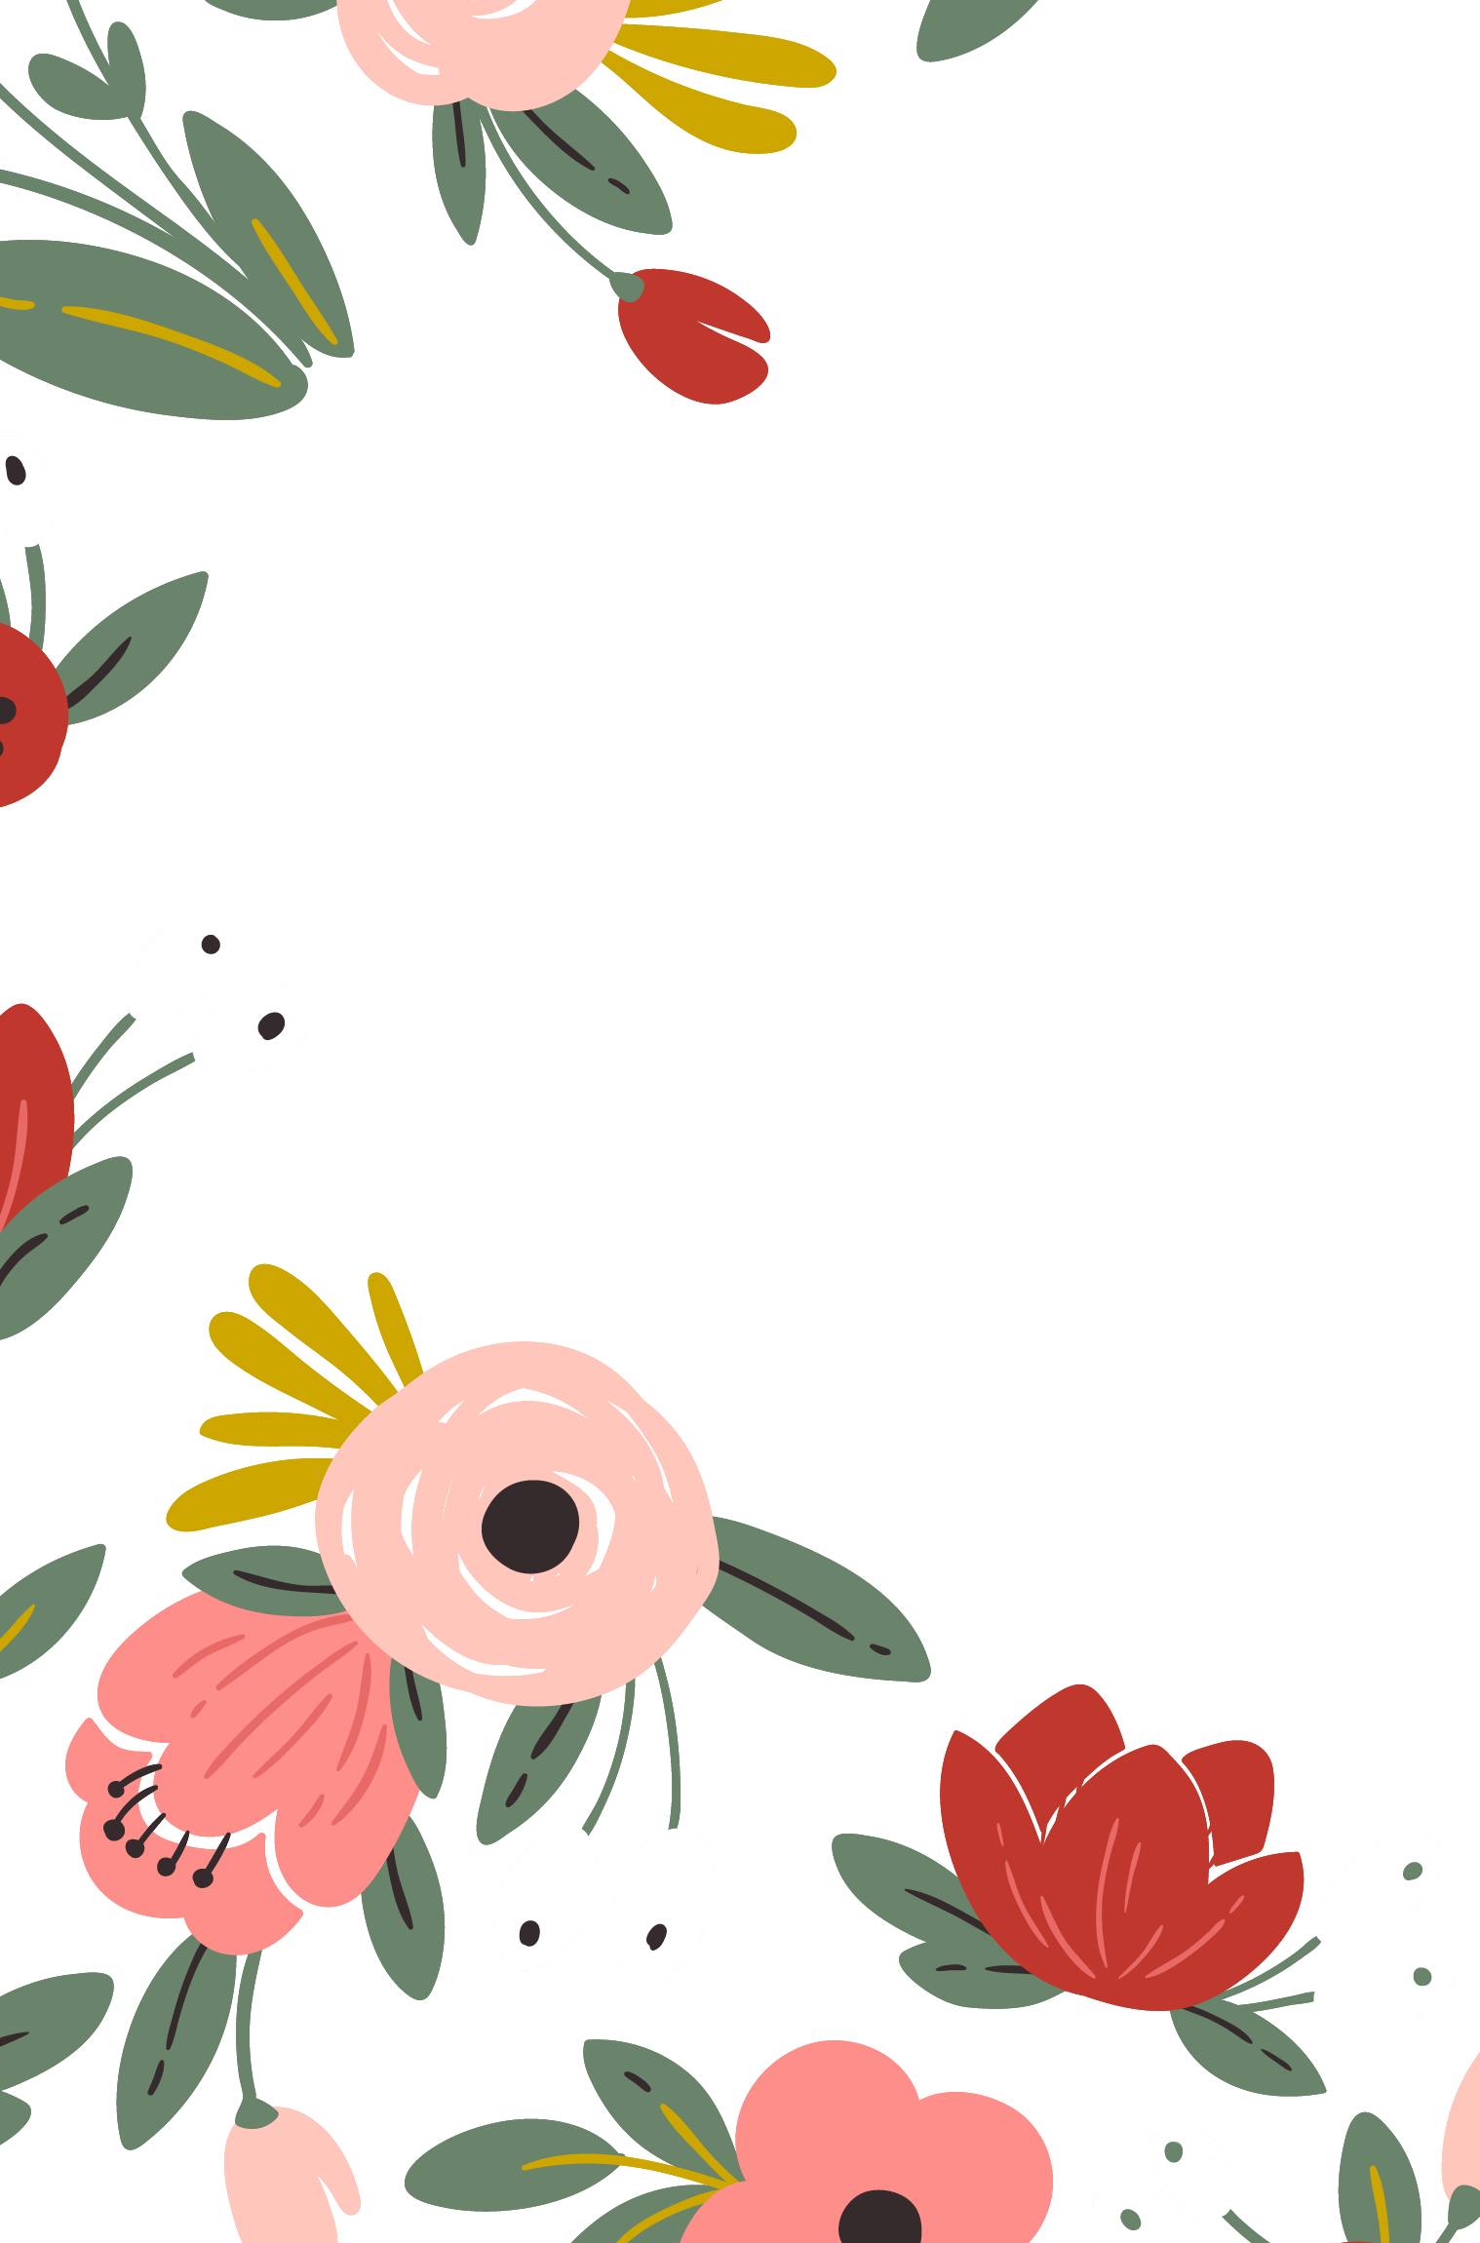

|  |  |
| --- | --- |
|  | 母亲节  **快乐** |

|  |  |  |
| --- | --- | --- |
|  | 感谢您让这个家  成为最快乐的地方。 |  |

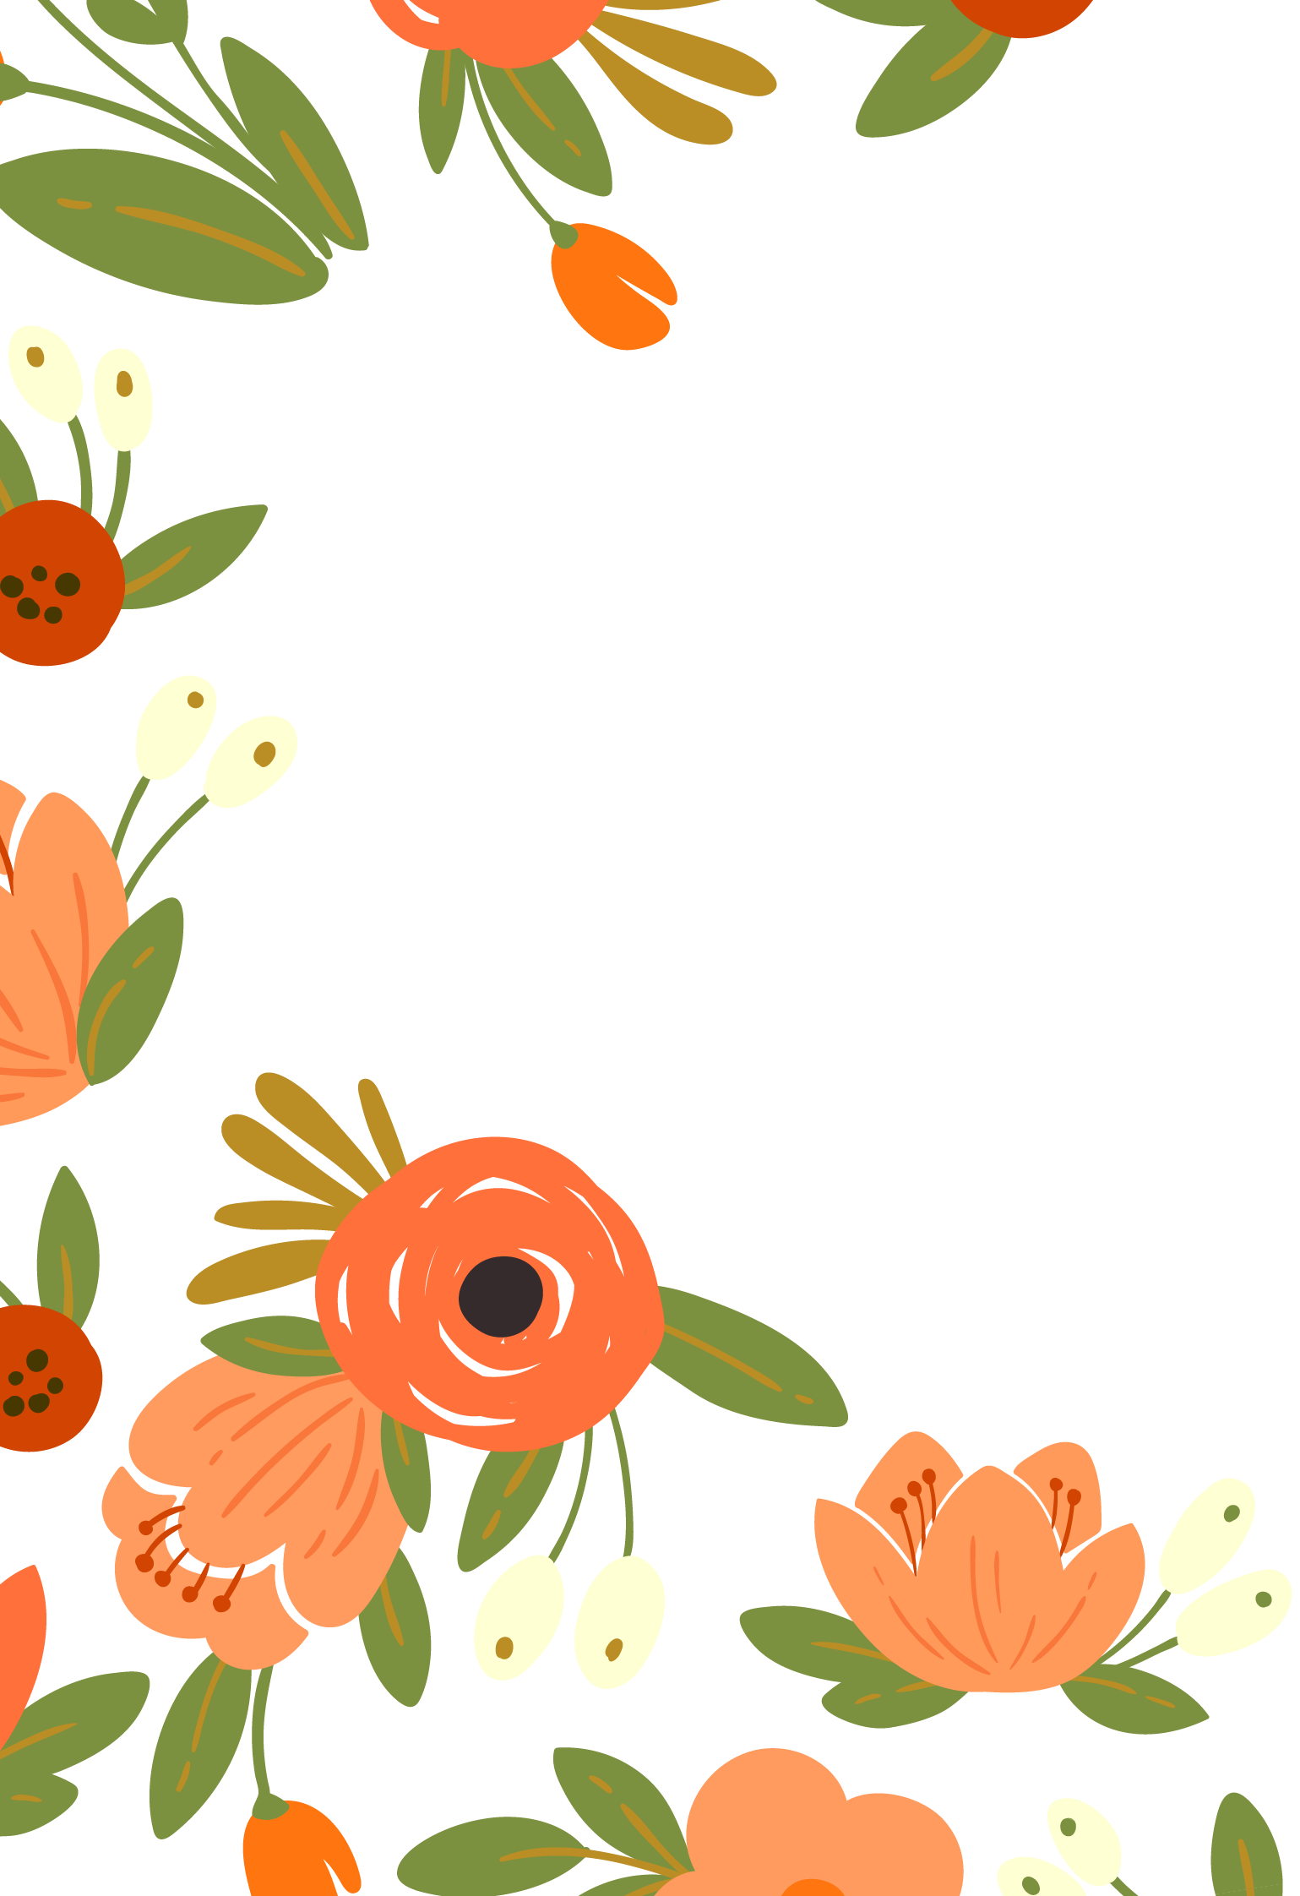

|  |  |
| --- | --- |
|  | 母亲节  **快乐** |

|  |  |  |
| --- | --- | --- |
|  | 感谢您让这个家  成为最快乐的地方。 |  |