|  |  |  |  |  |  |  |  |
| --- | --- | --- | --- | --- | --- | --- | --- |
| Januar 2010. | | | | | | | |
| Ponedeljak | Utorak | Sreda | Četvrtak | Petak | | Subota | Nedelja |
|  |  |  |  | 1 | | 2 | 3 |
| 4 | 5 | 6 | 7    PoslednjiKvartal  10:39 UT | 8 | | 9 | 10 |
| 11 | 12 | 13 | 14 | 15    Mlad Mesec  07:11 UT | Kružno pomračenje Sunca | 16 | 17 |
| 18 | 19 | 20    Vodolija | 21 | 22 | | 23    Prvi kvartal  10:53 UT | 24 |
| 25 | 26 | 27 | 28 | 29 | | 30    Pun Mesec  06:18 UT | 31 |

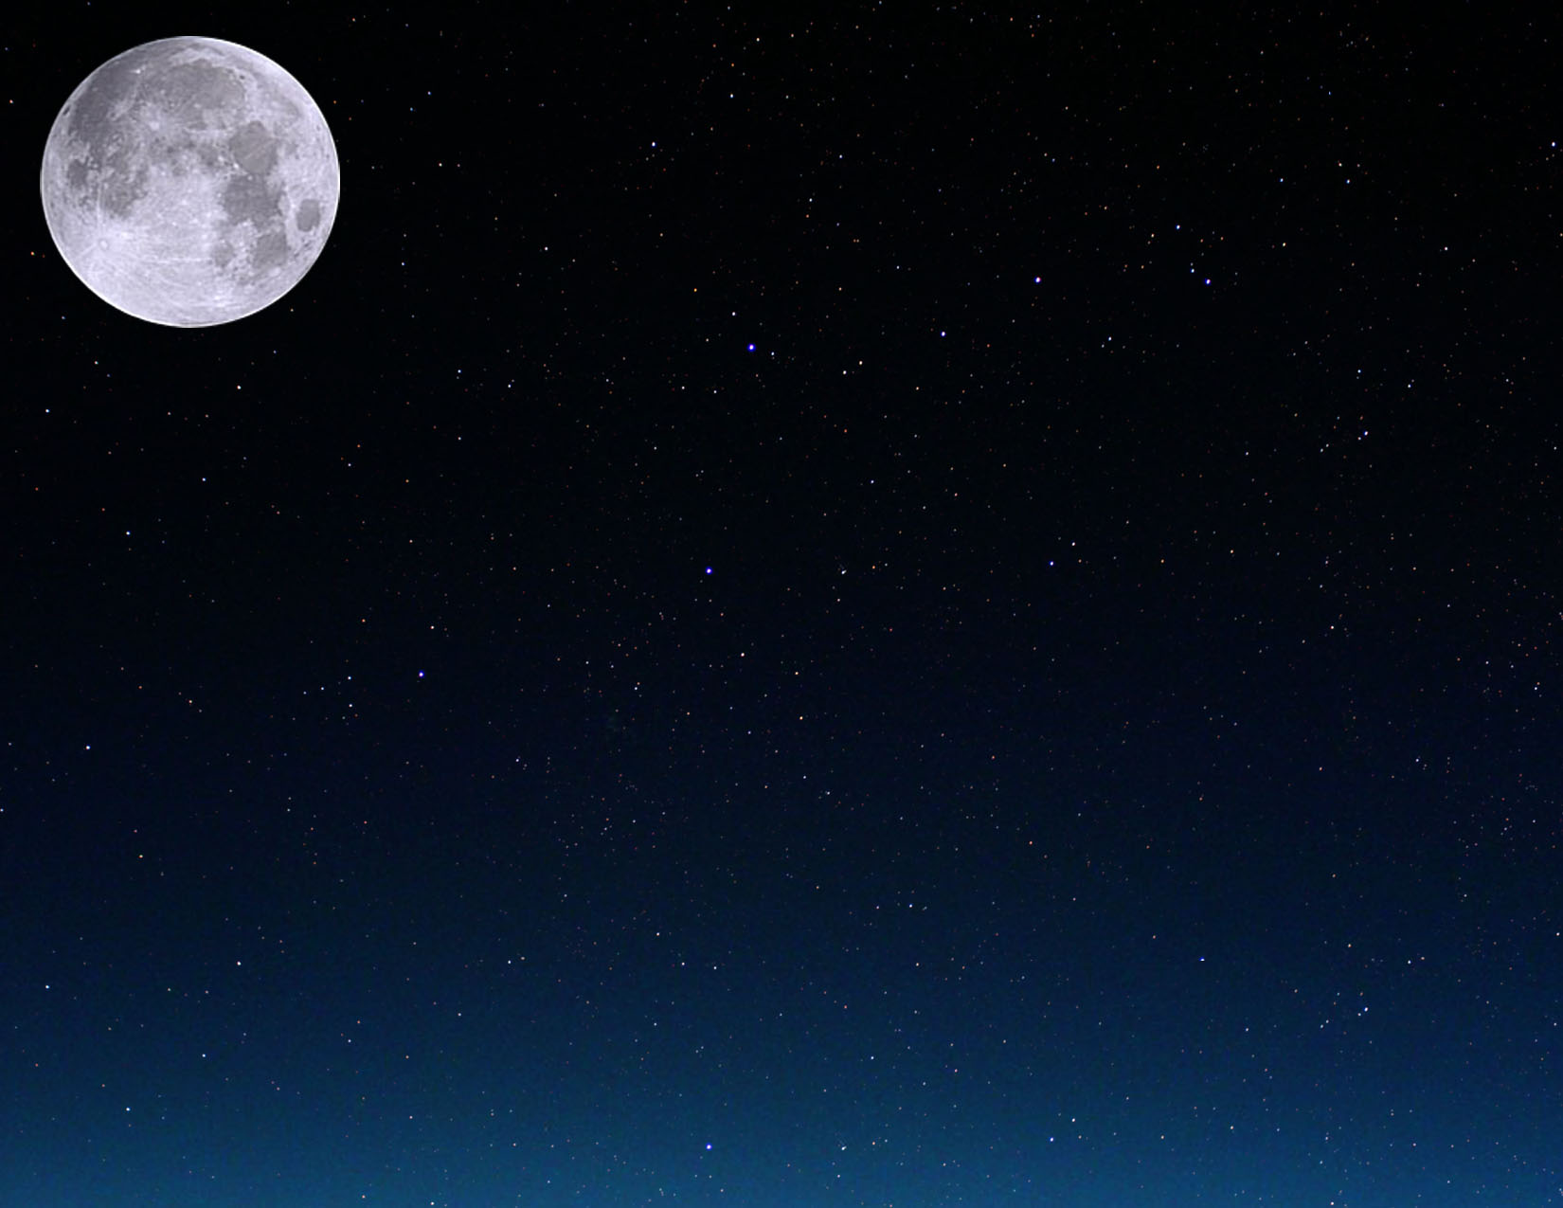

|  |  |  |  |  |  |  |
| --- | --- | --- | --- | --- | --- | --- |
| Februar2010. | | | | | | |
| Ponedeljak | Utorak | Sreda | Četvrtak | Petak | Subota | Nedelja |
| 1 | 2 | 3 | 4 | 5    PoslednjiKvartal  23:48 UT | 6 | 7 |
| 8 | 9 | 10 | 11 | 12 | 13 | 14    Mlad Mesec  02:51 UT |
| 15 | 16 | 17 | 18 | 19    Ribe | 20 | 21 |
| 22    Prvi kvartal  00:42 UT | 23 | 24 | 25 | 26 | 27 | 28    Pun Mesec  16:38 UT |

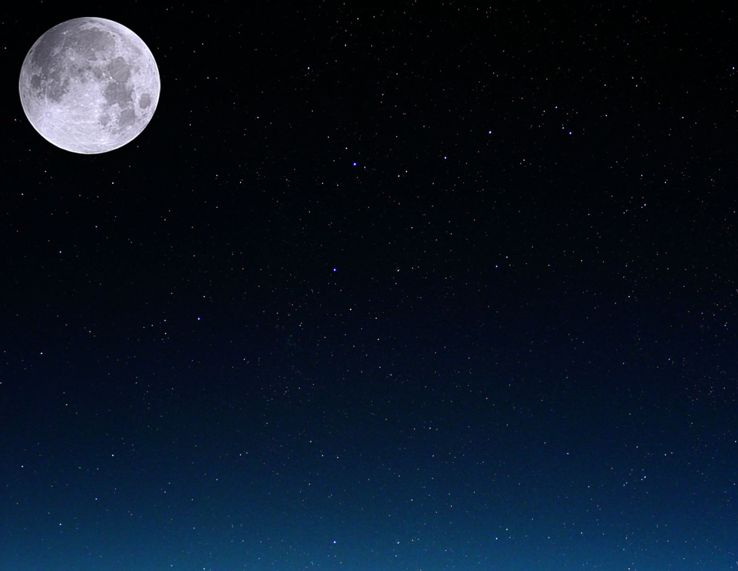

|  |  |  |  |  |  |  |
| --- | --- | --- | --- | --- | --- | --- |
| Mart2010. | | | | | | |
| Ponedeljak | Utorak | Sreda | Četvrtak | Petak | Subota | Nedelja |
| 1 | 2 | 3 | 4 | 5 | 6 | 7    PoslednjiKvartal  15:42 UT |
| 8 | 9 | 10 | 11 | 12 | 13 | 14 |
| 15    Mlad Mesec  21:01 UT | 16 | 17 | 18 | 19 | 20  Prolećna ravnodnevnica  17:32 UT | 21    Ovan |
| 22 | 23    Prvi kvartal  11:00 UT | 24 | 25 | 26 | 27 | 28 |
| 29 | 30    Pun Mesec  02:25 UT | 31 |  |  |  |  |

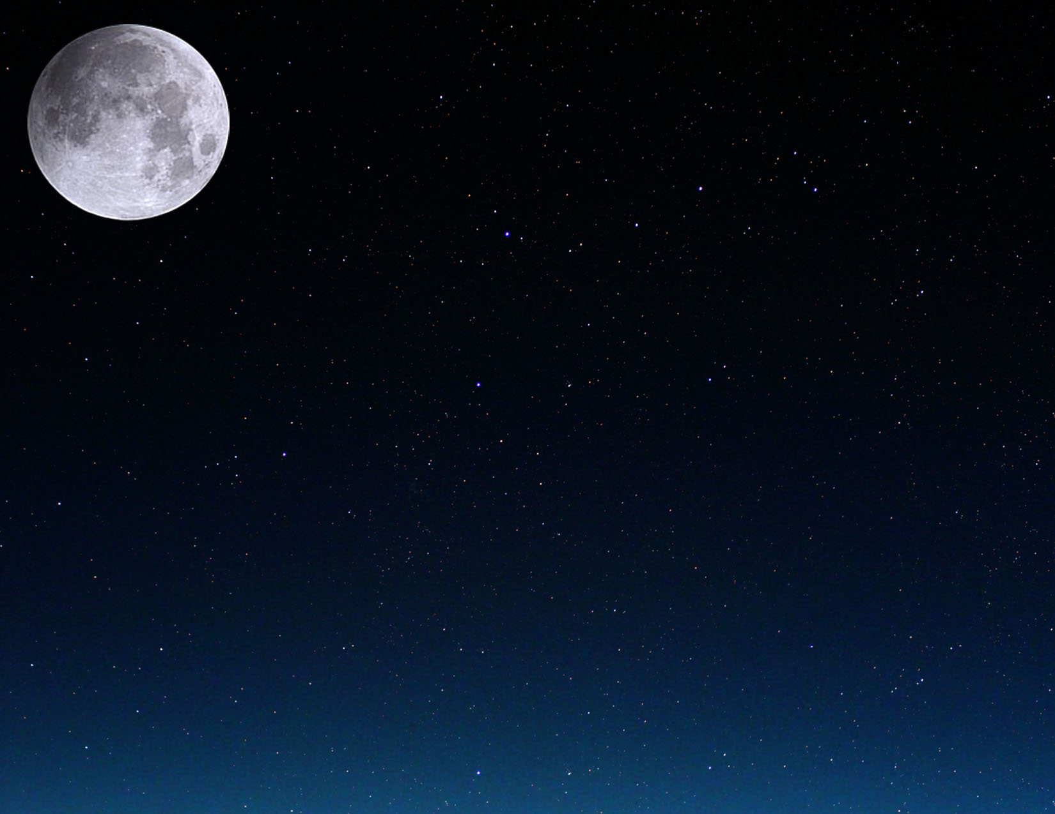

|  |  |  |  |  |  |  |
| --- | --- | --- | --- | --- | --- | --- |
| April2010. | | | | | | |
| Ponedeljak | Utorak | Sreda | Četvrtak | Petak | Subota | Nedelja |
|  |  |  | 1 | 2 | 3 | 4 |
| 5 | 6    PoslednjiKvartal  09:37 UT | 7 | 8 | 9 | 10 | 11 |
| 12 | 13 | 14    Mlad Mesec  12:29 UT | 15 | 16 | 17 | 18 |
| 19 | 20    Bik | 21    Prvi kvartal  18:20 UT | 22 | 23 | 24 | 25 |
| 26 | 27 | 28    Pun Mesec  12:18 UT | 29 | 30 |  |  |

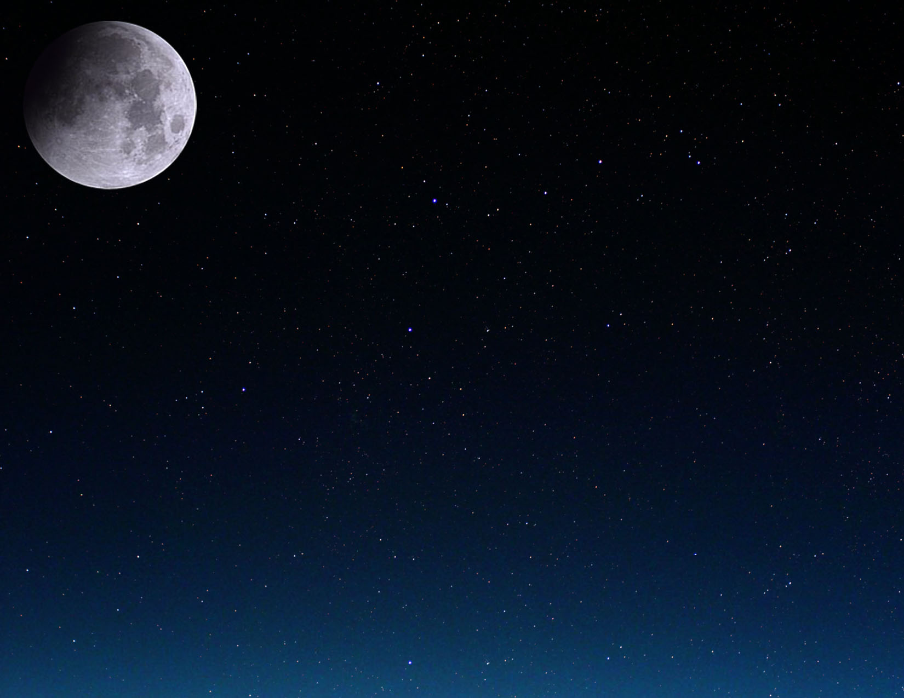

|  |  |  |  |  |  |  |
| --- | --- | --- | --- | --- | --- | --- |
| Maj 2010. | | | | | | |
| Ponedeljak | Utorak | Sreda | Četvrtak | Petak | Subota | Nedelja |
|  |  |  |  |  | 1 | 2 |
| 3 | 4 | 5 | 6    Poslednji Kvartal  04:15 UT | 7 | 8 | 9 |
| 10 | 11 | 12 | 13 | 14    Mlad Mesec  01:04 UT | 15 | 16 |
| 17 | 18 | 19 | 20    Prvi kvartal  23:43 UT | 21    Blizanci | 22 | 23 |
| 24 | 25 | 26 | 27    Pun Mesec  23:07 UT | 28 | 29 | 30 |
| 31 |  |  |  |  |  |  |

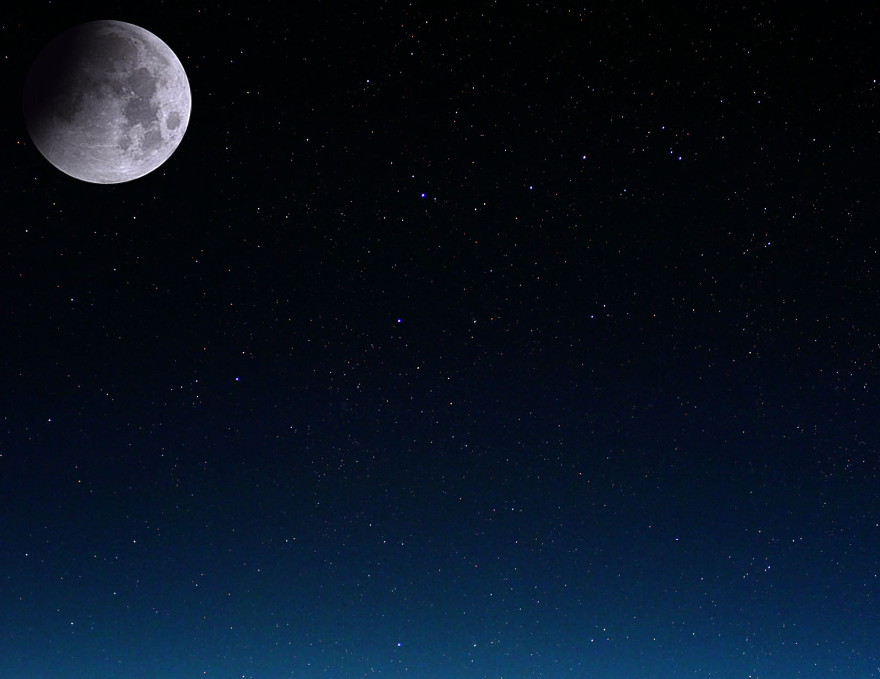

|  |  |  |  |  |  |  |  |
| --- | --- | --- | --- | --- | --- | --- | --- |
| Jun 2010. | | | | | | | |
| Ponedeljak | Utorak | Sreda | Četvrtak | Petak | Subota | | Nedelja |
|  | 1 | 2 | 3 | 4    Poslednji Kvartal  22:13 UT | 5 | | 6 |
| 7 | 8 | 9 | 10 | 11 | 12    Mlad Mesec  11:15 UT | | 13 |
| 14 | 15 | 16 | 17 | 18 | 19    Prvi kvartal  04:29 UT | | 20 |
| 21  Dugodnevica  11:28 UT | 22    Rak | 23 | 24 | 25 | 26    Pun Mesec  11:30 UT | Delimično pomračenje Meseca | 27 |
| 28 | 29 | 30 |  |  |  | |  |

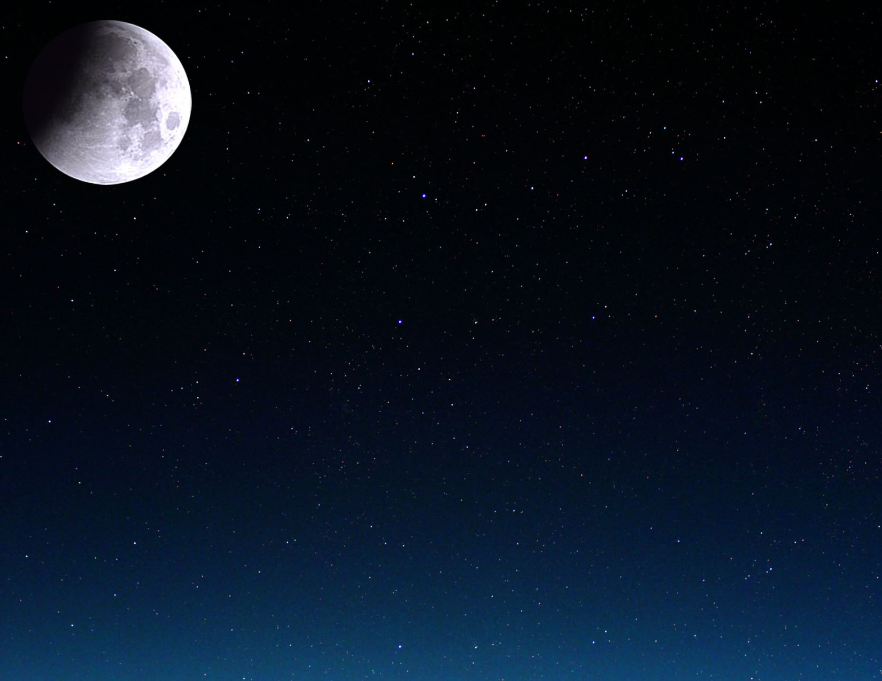

|  |  |  |  |  |  |  |  |
| --- | --- | --- | --- | --- | --- | --- | --- |
| Jul 2010. | | | | | | | |
| Ponedeljak | Utorak | Sreda | Četvrtak | Petak | Subota | Nedelja | |
|  |  |  | 1 | 2 | 3 | 4    Poslednji Kvartal  14:35 UT | |
| 5 | 6 | 7 | 8 | 9 | 10 | 11    Mlad Mesec  19:40 UT | Potpuno pomračenje Sunca |
| 12 | 13 | 14 | 15 | 16 | 17 | 18    Prvi kvartal  10:11 UT | |
| 19 | 20 | 21 | 22 | 23    Lav | 24 | 25 | |
| 26    Pun Mesec  01:37 UT | 27 | 28 | 29 | 30 | 31 |  | |

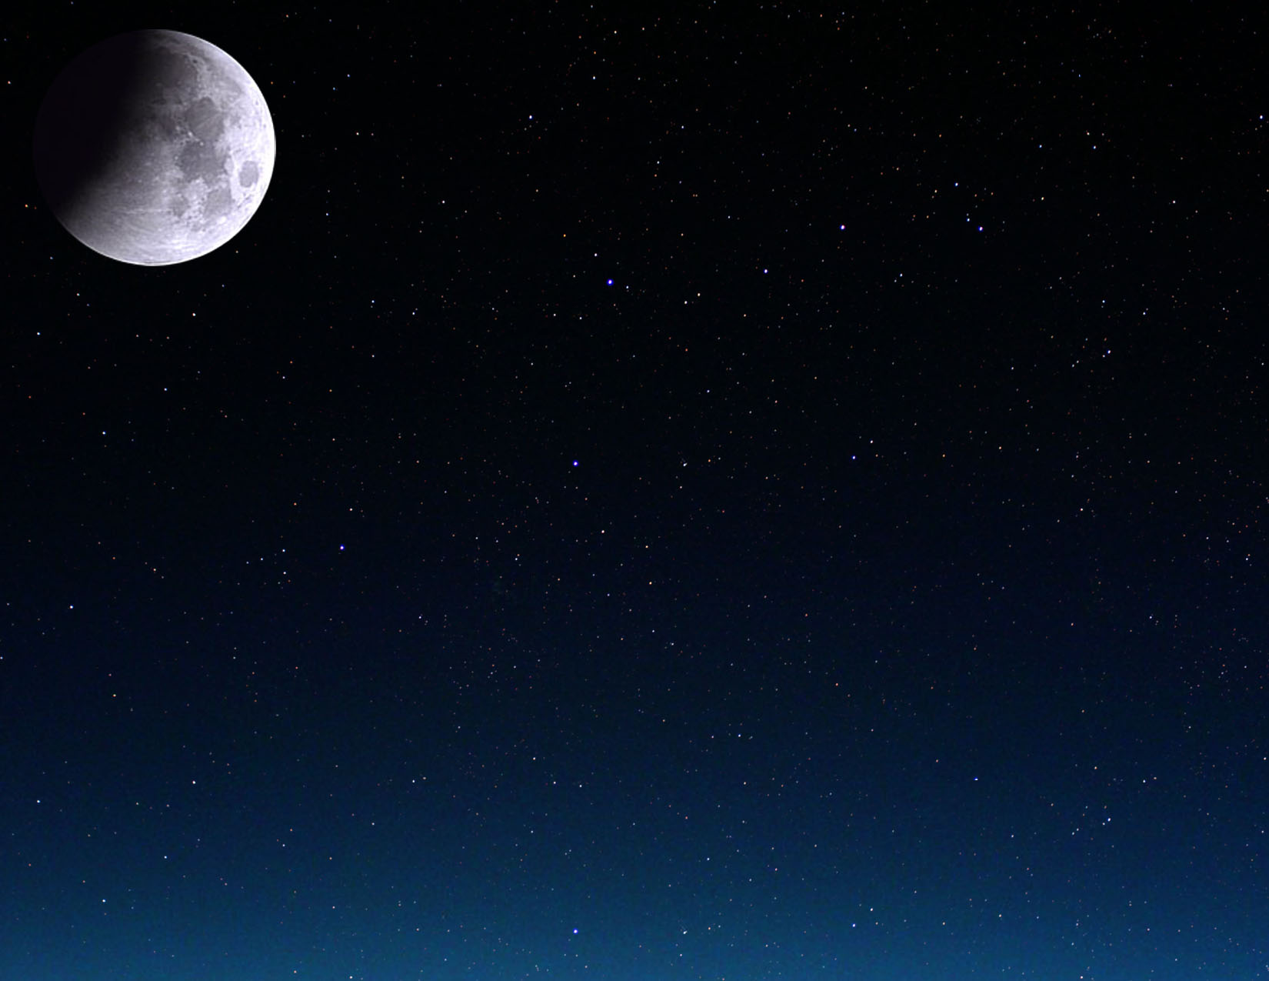

|  |  |  |  |  |  |  |
| --- | --- | --- | --- | --- | --- | --- |
| Avgust 2010. | | | | | | |
| Ponedeljak | Utorak | Sreda | Četvrtak | Petak | Subota | Nedelja |
|  |  |  |  |  |  | 1 |
| 2 | 3    Poslednji Kvartal  04:59 UT | 4 | 5 | 6 | 7 | 8 |
| 9 | 10    Mlad Mesec  03:08 UT | 11 | 12 | 13 | 14 | 15 |
| 16    Prvi kvartal  18:14 UT | 17 | 18 | 19 | 20 | 21 | 22 |
| 23    Devica | 24    Pun Mesec  17:05 UT | 25 | 26 | 27 | 28 | 29 |
| 30 | 31 |  |  |  |  |  |

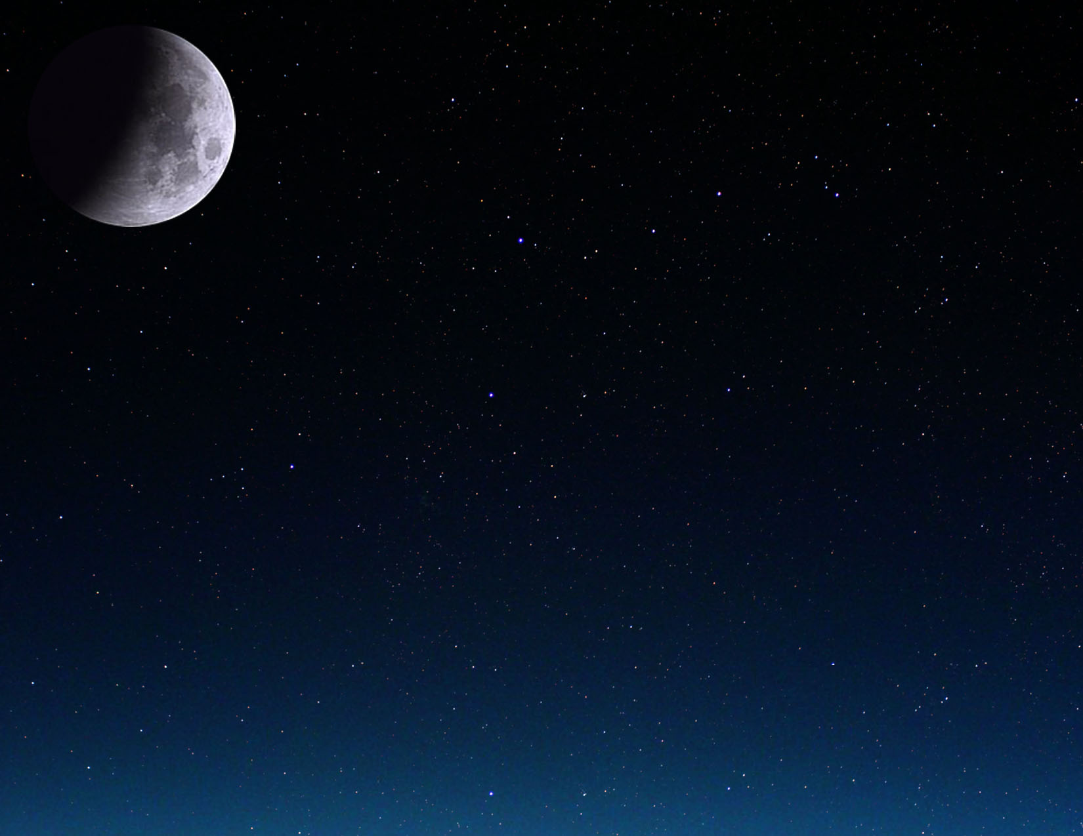

|  |  |  |  |  |  |  |  |
| --- | --- | --- | --- | --- | --- | --- | --- |
| Septembar 2010. | | | | | | | |
| Ponedeljak | Utorak | Sreda | Četvrtak | | Petak | Subota | Nedelja |
|  |  | 1    Poslednji Kvartal  17:22 UT | 2 | | 3 | 4 | 5 |
| 6 | 7 | 8    Mlad Mesec  10:30 UT | 9 | | 10 | 11 | 12 |
| 13 | 14 | 15    Prvi kvartal  05:50 UT | 16 | | 17 | 18 | 19 |
| 20 | 21 | 22  Jesenja ravnodnevica  03:09 UT | 23    Pun Mesec  09:17 UT | Vaga | 24 | 25 | 26 |
| 27 | 28 | 29 | 30 | |  |  |  |



|  |  |  |  |  |  |  |  |
| --- | --- | --- | --- | --- | --- | --- | --- |
| Oktobar 2010. | | | | | | | |
| Ponedeljak | Utorak | Sreda | Četvrtak | Petak | Subota | | Nedelja |
|  |  |  |  | 1    Poslednji Kvartal  03:52 UT | 2 | | 3 |
| 4 | 5 | 6 | 7    Mlad Mesec  18:44 UT | 8 | 9 | | 10 |
| 11 | 12 | 13 | 14    Prvi kvartal  21:27 UT | 15 | 16 | | 17 |
| 18 | 19 | 20 | 21 | 22 | 23    Pun Mesec  01:36 UT | Škorpija | 24 |
| 25 | 26 | 27 | 28 | 29 | 30    Poslednji Kvartal  12:46 UT | | 31 |

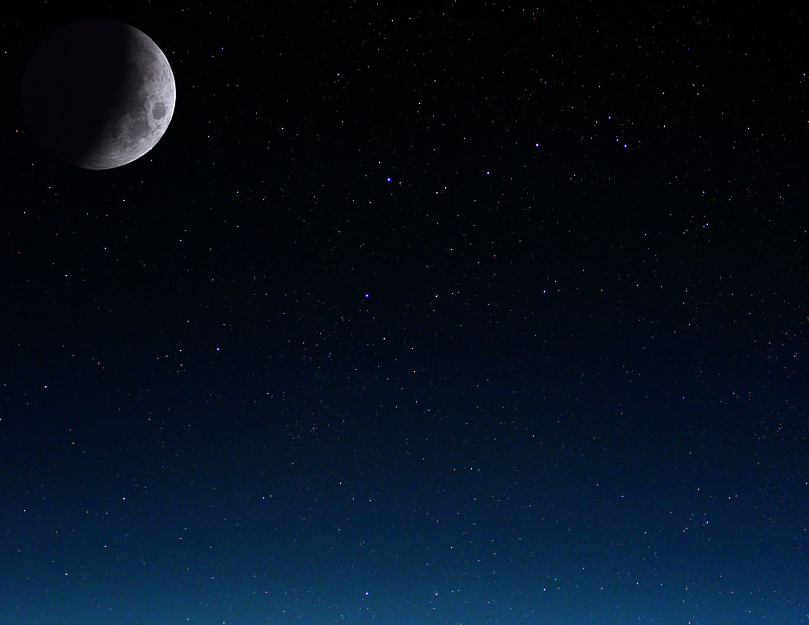

|  |  |  |  |  |  |  |
| --- | --- | --- | --- | --- | --- | --- |
| Novembar 2010. | | | | | | |
| Ponedeljak | Utorak | Sreda | Četvrtak | Petak | Subota | Nedelja |
| 1 | 2 | 3 | 4 | 5 | 6    Mlad Mesec  04:52 UT | 7 |
| 8 | 9 | 10 | 11 | 12 | 13    Prvi kvartal  16:39 UT | 14 |
| 15 | 16 | 17 | 18 | 19 | 20 | 21    Pun Mesec  17:27 UT |
| 22    Strelac | 23 | 24 | 25 | 26 | 27 | 28    Poslednji Kvartal  20:36 UT |
| 29 | 30 |  |  |  |  |  |

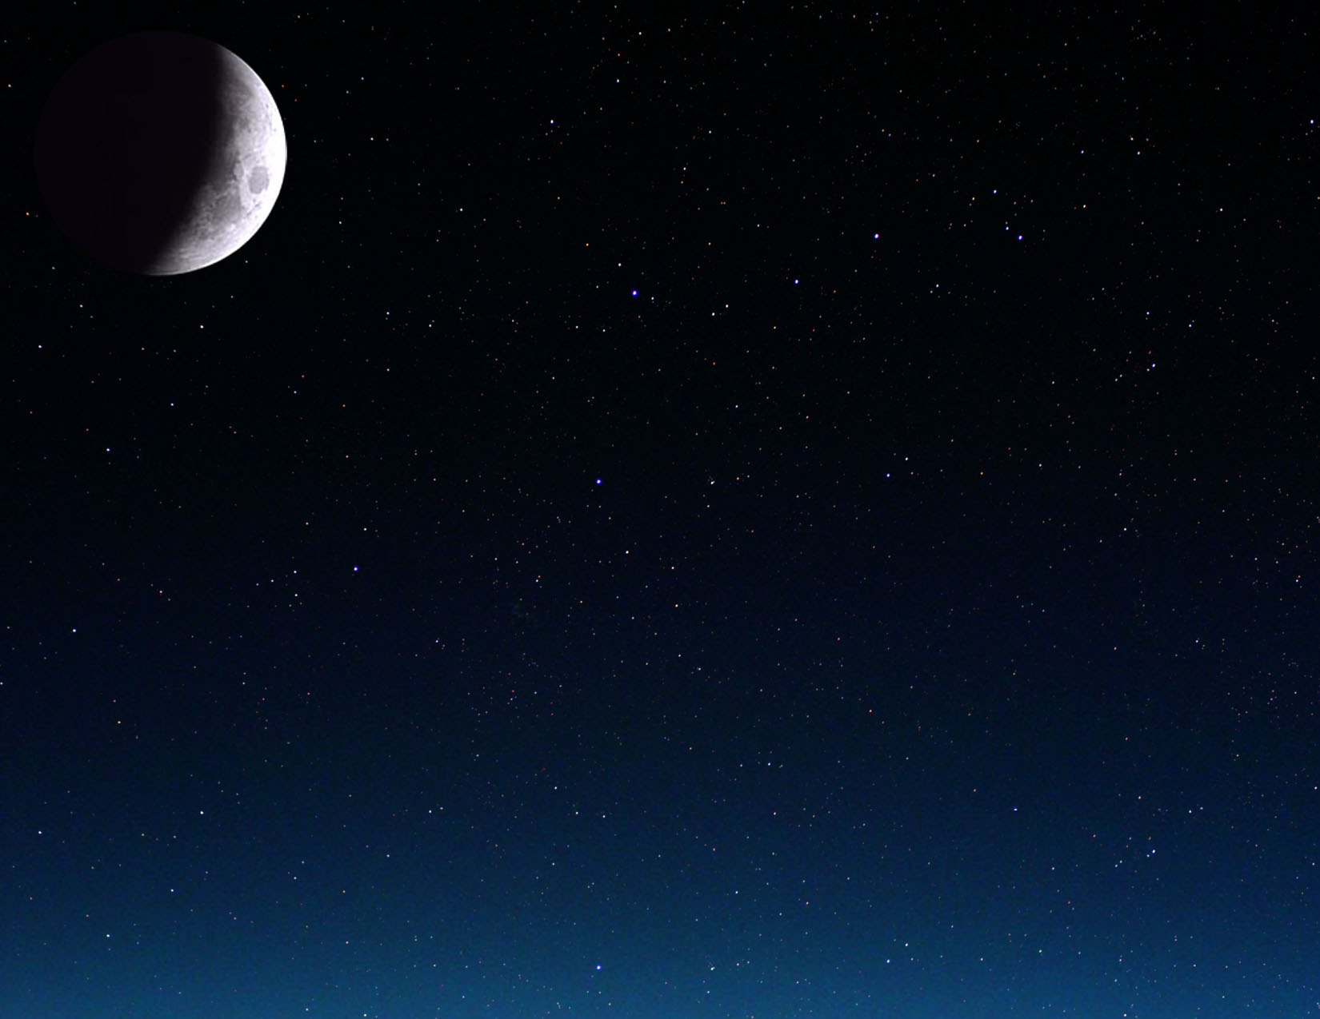

|  |  |  |  |  |  |  |  |
| --- | --- | --- | --- | --- | --- | --- | --- |
| Decembar2010. | | | | | | | |
| Ponedeljak | Utorak | | Sreda | Četvrtak | Petak | Subota | Nedelja |
|  |  | | 1 | 2 | 3 | 4 | 5    Mlad Mesec  17:36 UT |
| 6 | 7 | | 8 | 9 | 10 | 11 | 12 |
| 13    Prvi kvartal  13:59 UT | 14 | | 15 | 16 | 17 | 18 | 19 |
| 20 | 21    Pun Mesec  08:13 UT | Kratkodnevica  23:38 UT  Potpuno pomračenje Meseca | 22    Jarac | 23 | 24 | 25 | 26 |
| 27 | 28    Poslednji Kvartal  04:18 UT | | 29 | 30 | 31 |  |  |

