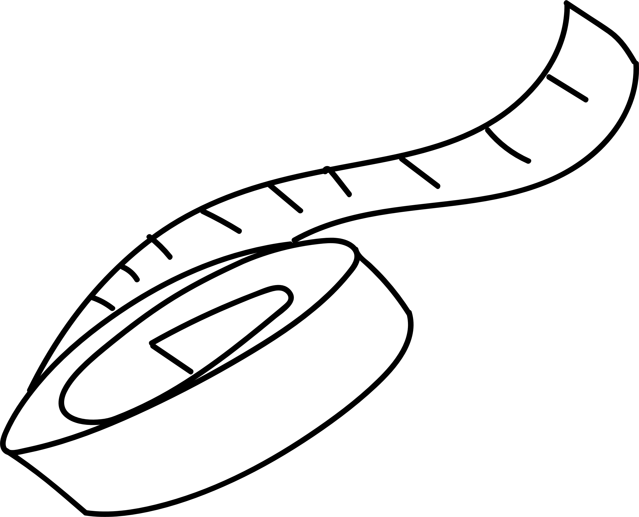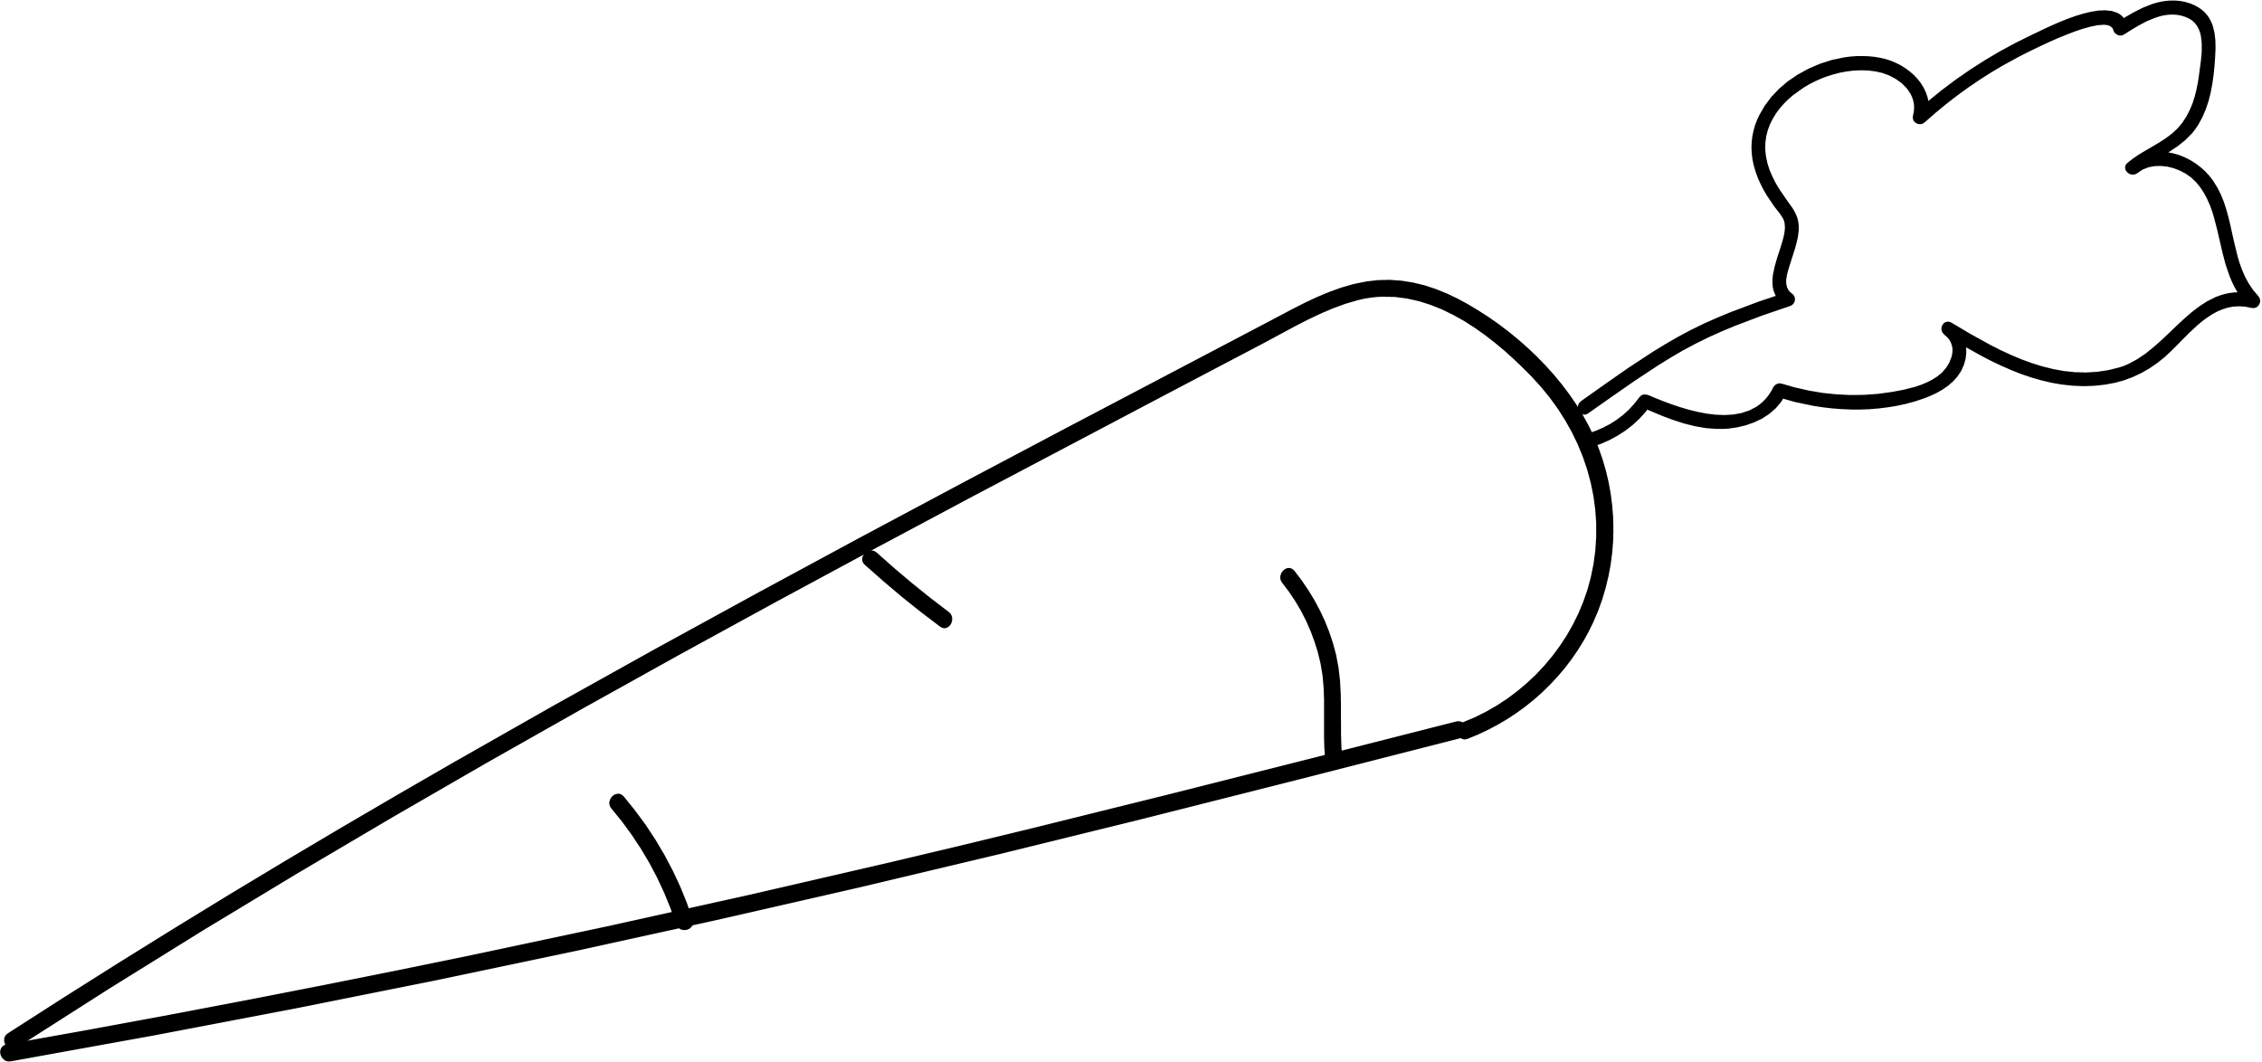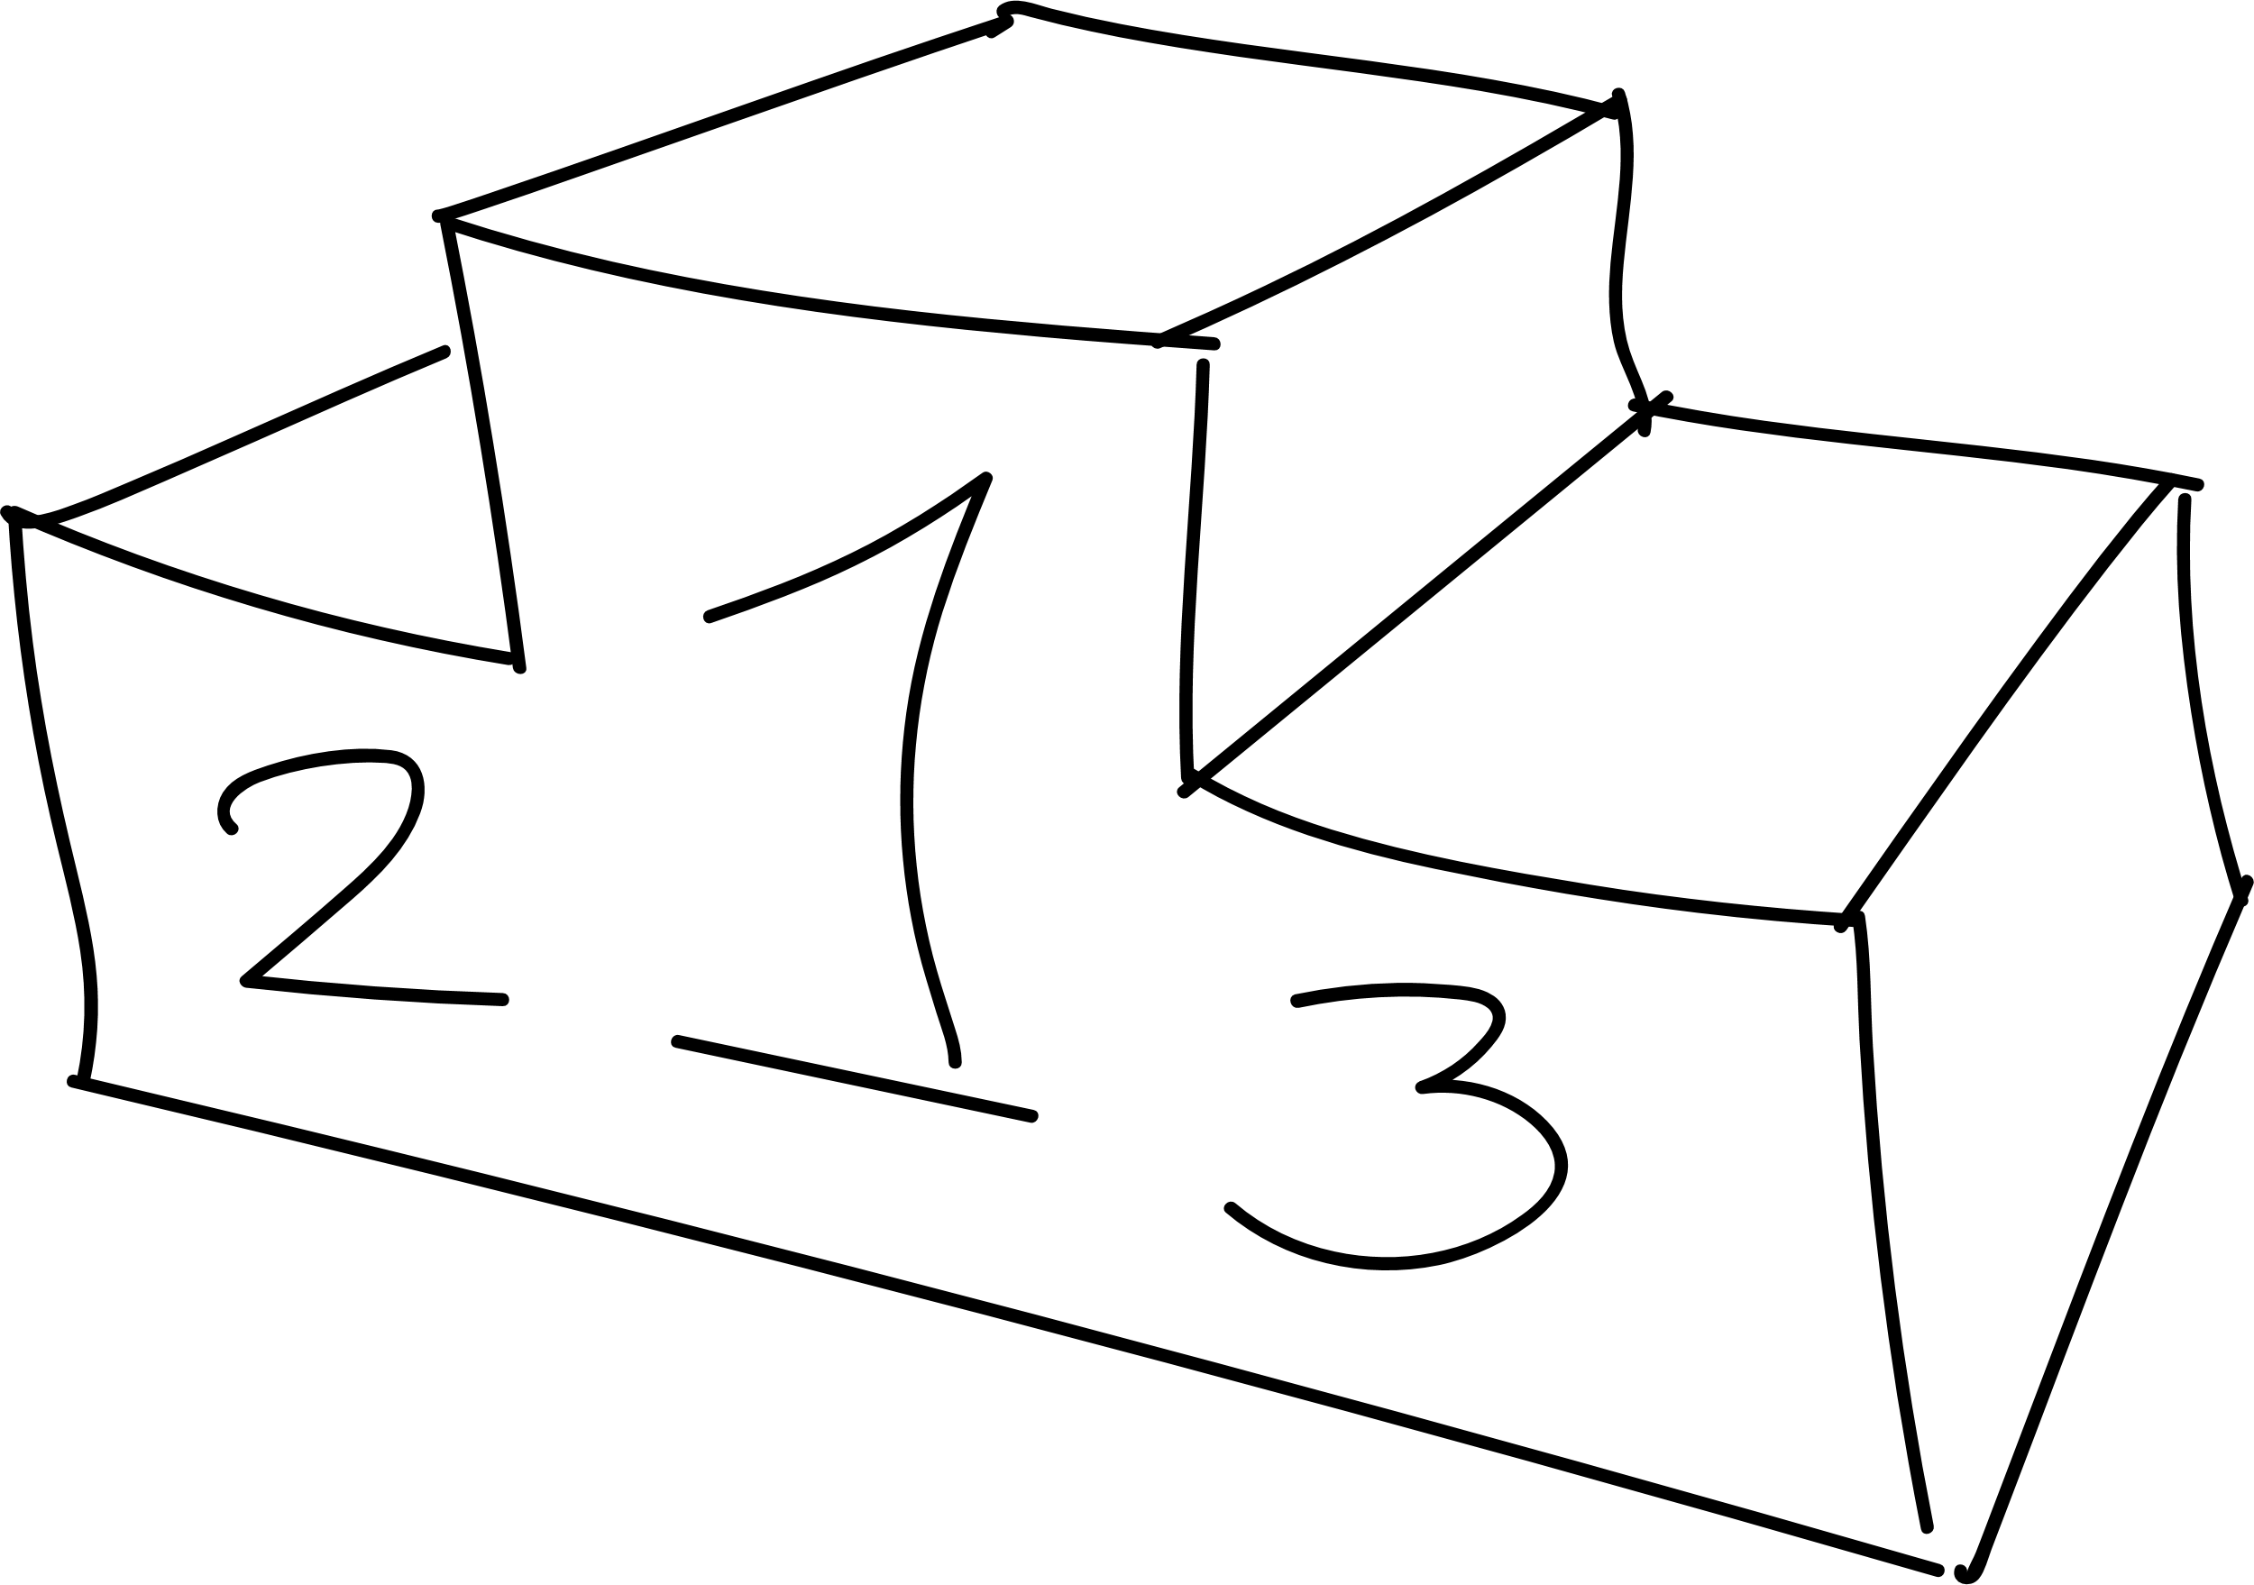

20XX



ЖУРНАЛ  
ПИТАНИЯ

Lorem Ipsum Dolor



# Идеи для полезного питания



|  |  |  |  |  |  |  |  |  |  |  |
| --- | --- | --- | --- | --- | --- | --- | --- | --- | --- | --- |
|  | Орехи |  |  |  | Овощи |  |  |  | Фрукты |  |
|  |  |  |  |  |  |  |
|  | | |  |  | | |  |  | | |
|  | | |  | | |  |  |  |  |
|  | | |  | | |  |  | | |
|  |  |  |  | | |  |  | | |
|  |  |  |  |  |  |  |  |  |  |
|  | Морепродукты |  |  |  | Рыба |  |  |  | Сладкое |  |
|  |  |  |  |  |  |  |  |
|  | | |  |  | | |  |  | | |
|  | | |  |  | | |  |  | | |
|  | | |  |  |  |  |  |  | | |
|  | | |  |  |  |  |  |  |  |  |
|  |  |  |  |  |  |  |  |  |  |  |

|  |  |  |
| --- | --- | --- |
|  | Другое |  |
|  |  |
|  | | |
|  | | |
|  | | |

# Журнал питания на неделю



|  |  |  |  |  |  |
| --- | --- | --- | --- | --- | --- |
|  | Вс |  | Пн |  | Вт |
|  |  |  |  |  |  |
|  |  |  |  |  |  |
|  |  |  |  |  |  |
|  |  |  |  |  |  |
|  |  |  |  |  |  |
|  |  |  |  |  |  |
|  | Ср |  | Чт |  | Заметки |
|  |  |  |  |  |  |
|  |  |  |  |  |  |
|  |  |  |  |  |  |
|  |  |  |  |  |  |
|  |  |  |  |  |  |
|  |  |  |  |  |  |
|  | Пт |  | Сб |  |  |
|  |  |  |  |
|  |  |  |  |  |  |
|  |  |  |  |  |  |
|  |  |  |  |  |  |
|  |  |  |  |  |  |
|  |  |  |  |  |  |

# Журнал потребления воды



## Месяц

|  |  |  |  |
| --- | --- | --- | --- |
| 1 |  | 16 |  |
| 2 |  | 17 |  |
| 3 |  | 18 |  |
| 4 |  | 19 |  |
| 5 |  | 20 |  |
| 6 |  | 21 |  |
| 7 |  | 22 |  |
| 8 |  | 23 |  |
| 9 |  | 24 |  |
| 10 |  | 25 |  |
| 11 |  | 26 |  |
| 12 |  | 27 |  |
| 13 |  | 28 |  |
| 14 |  | 29 |  |
| 15 |  | 30 |  |

##### Контроль веса



|  |  |  |  |  |  |  |  |  |  |  |  |  |
| --- | --- | --- | --- | --- | --- | --- | --- | --- | --- | --- | --- | --- |
|  | Янв | Фев | Мар | Апр | Май | Июн | Июл | Авг | Сен | Окт | Ноя | Дек |
| 50 |  |  |  |  |  |  |  |  |  |  |  |  |
| 49 |  |  |  |  |  |  |  |  |  |  |  |  |
| 48 |  |  |  |  |  |  |  |  |  |  |  |  |
| 47 |  |  |  |  |  |  |  |  |  |  |  |  |
| 46 |  |  |  |  |  |  |  |  |  |  |  |  |
| 45 |  |  |  |  |  |  |  |  |  |  |  |  |
| 44 |  |  |  |  |  |  |  |  |  |  |  |  |
| 43 |  |  |  |  |  |  |  |  |  |  |  |  |
| 42 |  |  |  |  |  |  |  |  |  |  |  |  |
| 41 |  |  |  |  |  |  |  |  |  |  |  |  |
| 40 |  |  |  |  |  |  |  |  |  |  |  |  |
| 39 |  |  |  |  |  |  |  |  |  |  |  |  |
| 38 |  |  |  |  |  |  |  |  |  |  |  |  |

##### Измерения



|  |  |  |  |  |  |  |
| --- | --- | --- | --- | --- | --- | --- |
|  | Янв | Мар | Май | Июл | Сен | Ноя |
| Грудь |  |  |  |  |  |  |
| Таз |  |  |  |  |  |  |
| Левое бедро |  |  |  |  |  |  |
| Правое бедро |  |  |  |  |  |  |
| Левая рука |  |  |  |  |  |  |
| Правая рука |  |  |  |  |  |  |

# Здоровые вознаграждения



|  |  |  |
| --- | --- | --- |
| Начало |  | Этап 1 |
|  |
|  |
|  |  | Этап 3 |
| Завершение |  |  |



|  |  |
| --- | --- |
|  | Этап 2 |
|  | Этап 4 |



# Цели питания



|  |  |  |
| --- | --- | --- |
|  | Группа целей 1 |  |
|  |  |
|  | | |
|  | | |
|  | | |
|  | | |

|  |  |  |  |  |  |  |
| --- | --- | --- | --- | --- | --- | --- |
|  | Группа целей 2 |  |  |  | Группа целей 3 |  |
|  |  |  |  |
|  |  |  |  |  |  |  |
|  |  |  |  |  |  |  |
|  |  |  |  |  |  |  |
|  |  |  |  |  |  |  |
|  |  |  |  |  |  |  |

|  |  |  |
| --- | --- | --- |
|  | Группа целей 4 |  |
|  |  |
|  | | |
|  | | |
|  | | |
|  | | |