

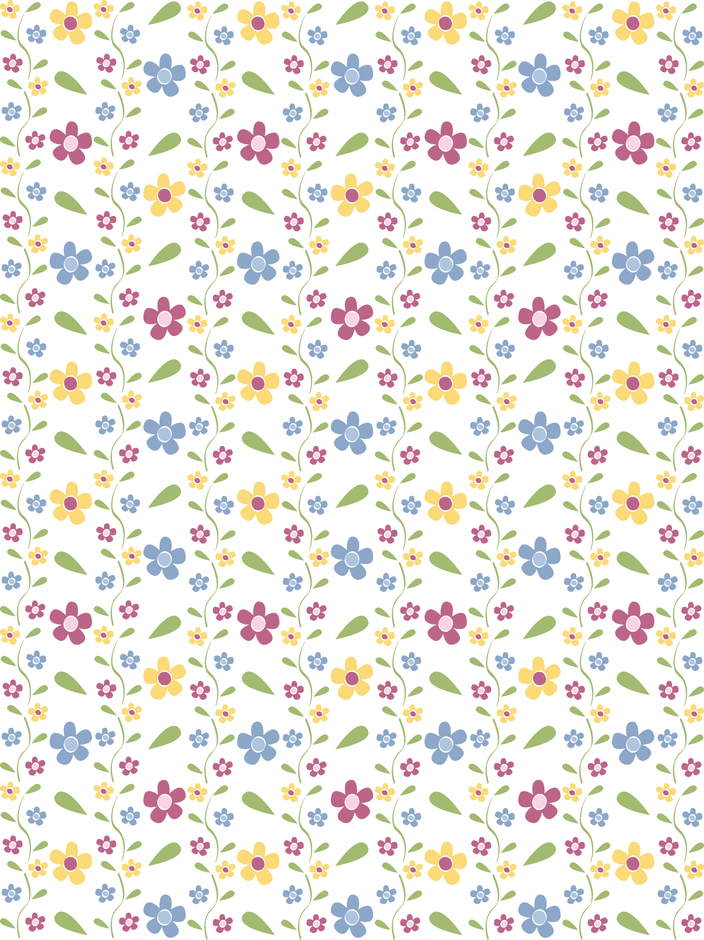

|  |  |
| --- | --- |
|  | |
| Our Baby | |
|  | |
|  | |
| Born: at in | |
| Weight: | Length: |



|  |  |
| --- | --- |
|  | |
| First Month | |
|  | |
| Date: | |
| Weight: | Length: |
| Notes: | |



|  |  |
| --- | --- |
|  | |
| Second Month | |
|  | |
| Date: | |
| Weight: | Length: |
| Notes: | |



|  |  |
| --- | --- |
|  | |
| Third Month | |
|  | |
| Date: | |
| Weight: | Length: |
| Notes: | |



|  |  |
| --- | --- |
|  | |
| Fourth Month | |
|  | |
| Date: | |
| Weight: | Length: |
| Notes: | |



|  |  |
| --- | --- |
|  | |
| Fifth Month | |
|  | |
| Date: | |
| Weight: | Length: |
| Notes: | |



|  |  |
| --- | --- |
|  | |
| Sixth Month | |
|  | |
| Date: | |
| Weight: | Length: |
| Notes: | |



|  |  |
| --- | --- |
|  | |
| Seventh Month | |
|  | |
| Date: | |
| Weight: | Length: |
| Notes: | |

|  |  |
| --- | --- |
| bgirl_blueflower | |
| Eighth Month | |
|  | |
| Date: | |
| Weight: | Length: |
| Notes: | |



|  |  |
| --- | --- |
|  | |
| Nineth Month | |
|  | |
| Date: | |
| Weight: | Length: |
| Notes: | |



|  |  |
| --- | --- |
|  | |
| Tenth Month | |
|  | |
| Date: | |
| Weight: | Length: |
| Notes: | |



|  |  |
| --- | --- |
|  | |
| Eleventh Month | |
|  | |
| Date: | |
| Weight: | Length: |
| Notes: | |



|  |  |
| --- | --- |
|  | |
| Twelfth Month | |
|  | |
| Date: | |
| Weight: | Length: |
| Notes: | |