Sunspot Nursery

98765 Main Street

Savannah, GA 98031

Located in Harrington across from Memorial Park

Logo placeholder

Don’t miss out on your chance to SAVE!

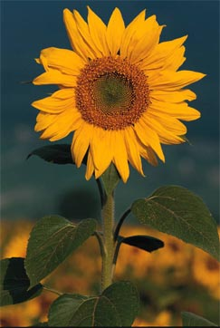

All decorative items

25% off!

Specially marked housewares

30% off!

10-inch potted sunflower plants

$3 each

Mini-greenhouse displays

$7 each

Sale!

Sale prices good through 11/17/03

Store Hours:

10:00 A.M. – 5:00 P.M. (M thru F)

9:00 A.M. – 6:00 P.M. (Sat. & Sun.)