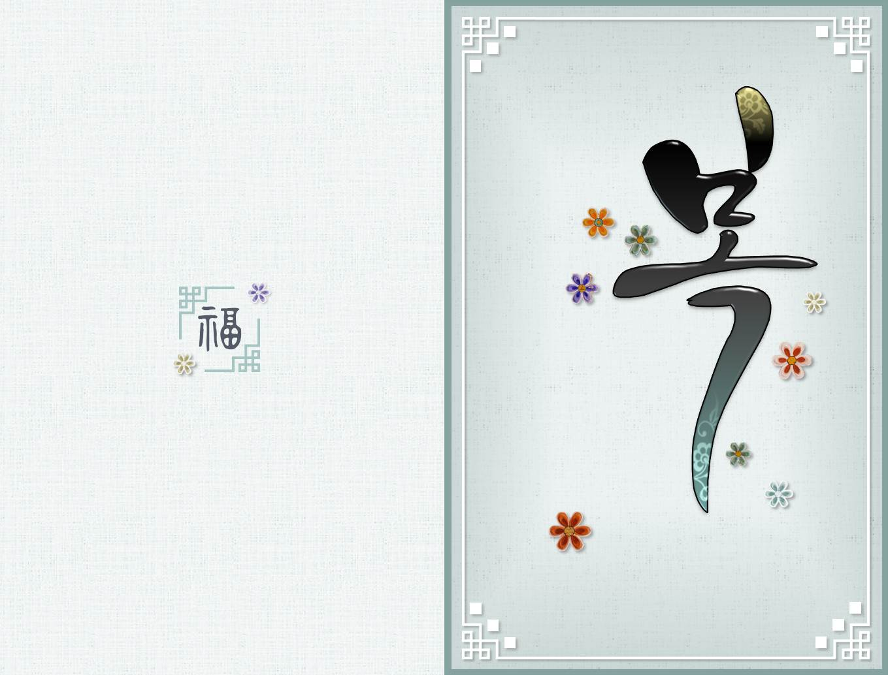

**새해 복 많이 받으세요**

Season’s Greetings and Best Wishes for a Happy New Year!

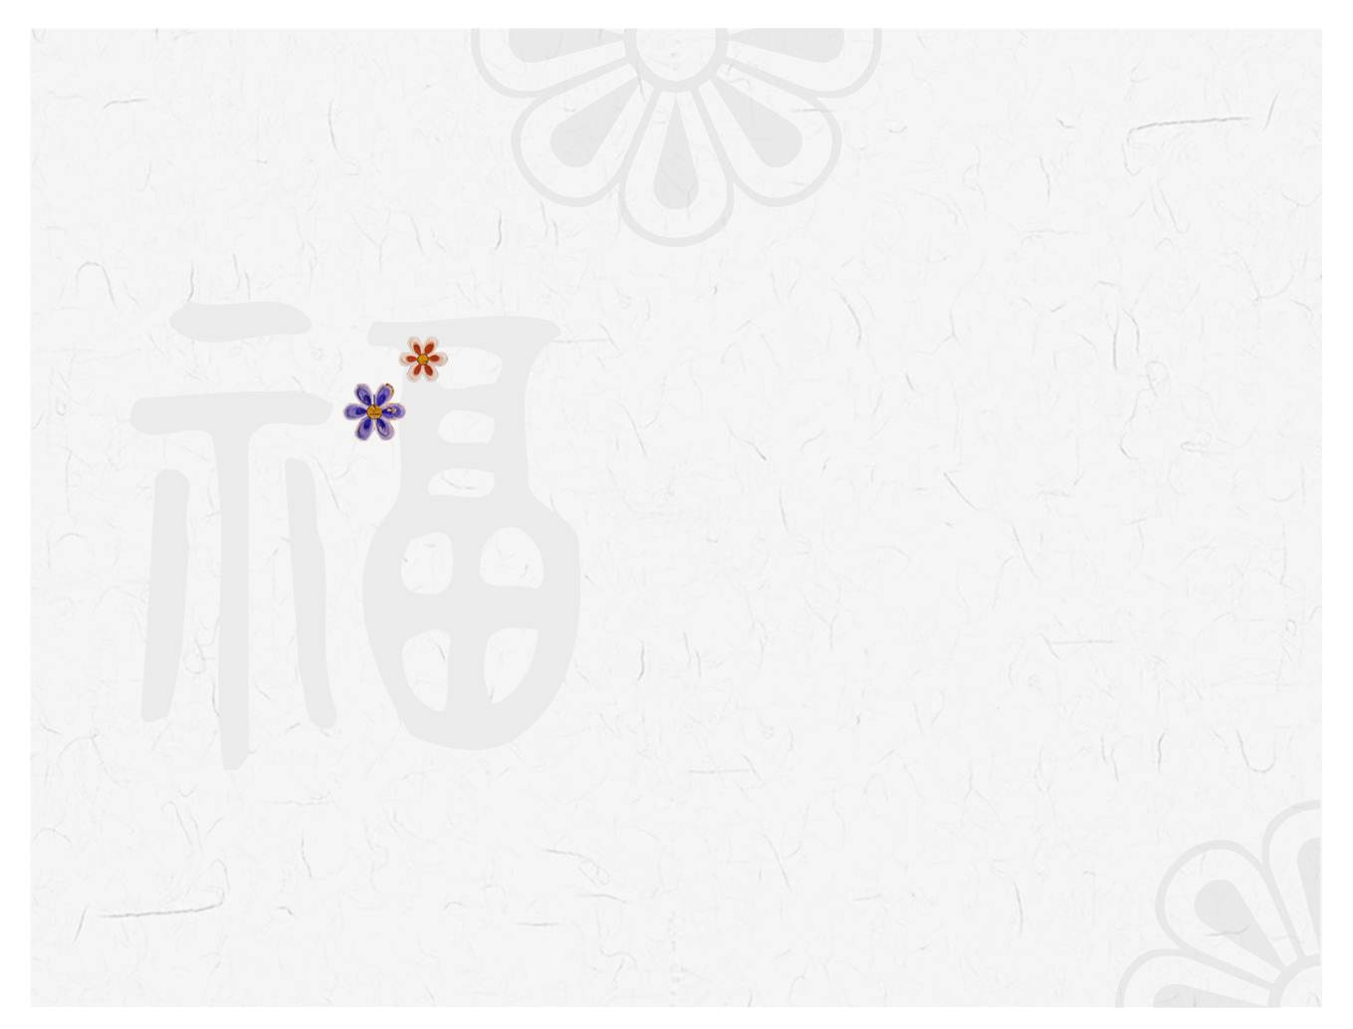

Season’s Greetings

and

Best Wishes for a Happy New Year!