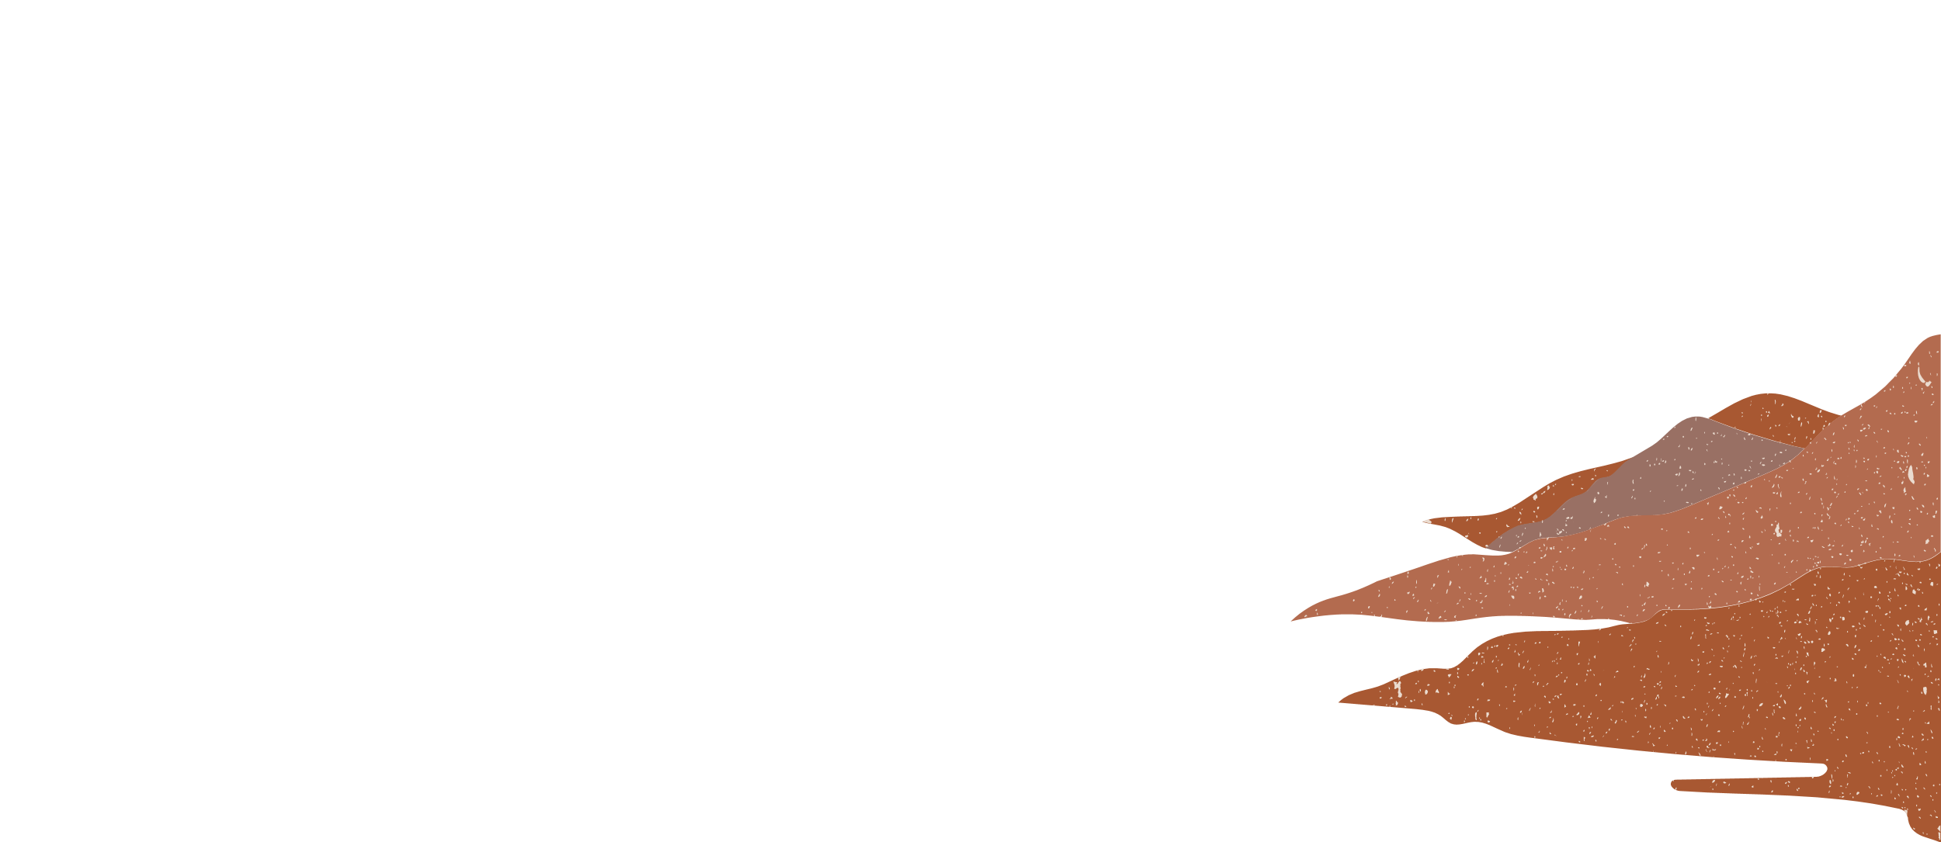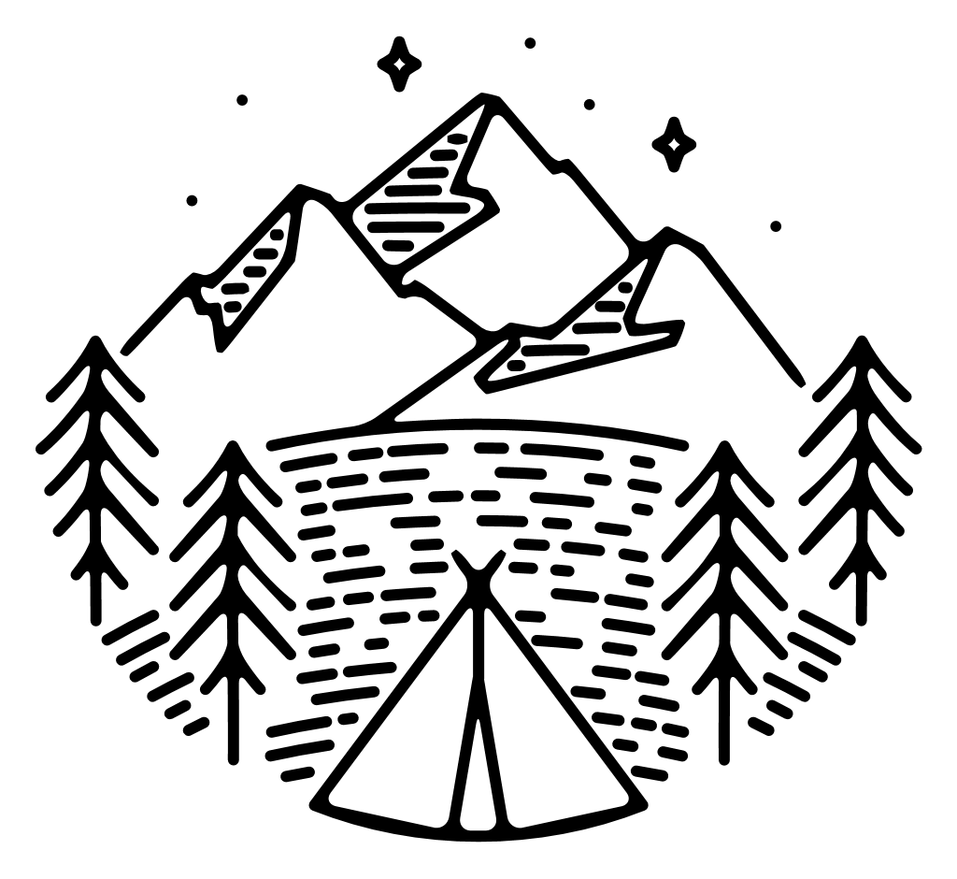

自社のロゴ

|  |  |
| --- | --- |
| Northwind Traders  234 5th Ave.  Madison, WI 54321 |  |
|  | Terje Möttölä  987 6th Ave.  Santa Fe, NM 12345 |