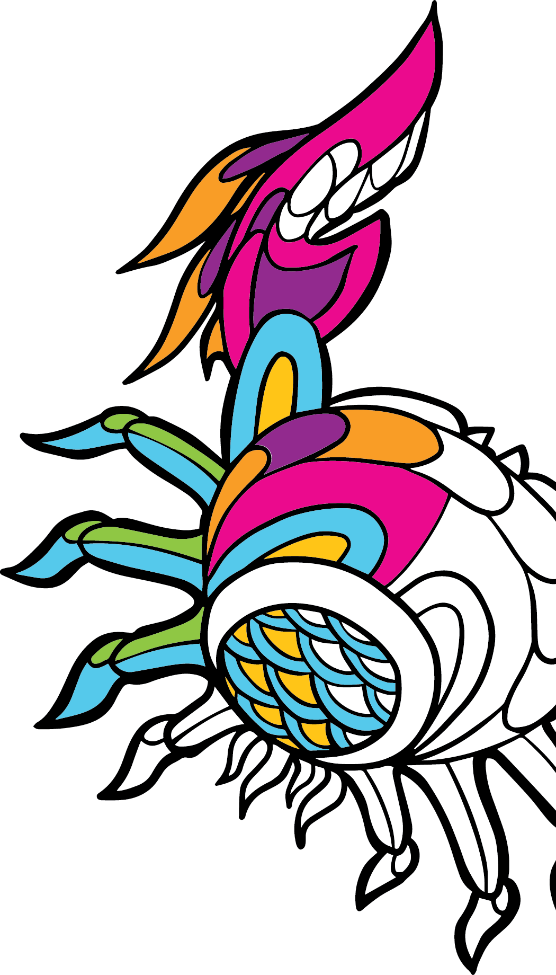

|  |  |
| --- | --- |
| Art  du Nord-Ouest Pacifique  Livre de coloriage |  |
| [**https://stayinsidethelines.co**](https://stayinsidethelines.co/) | |

|  |
| --- |
| image abstraite à colorier |
| Jesse Brown |

|  |
| --- |
| image à colorier de fleurs et autres formes |
| Josephine Rice |

|  |
| --- |
| image abstraite à colorier |
| Keper |

|  |
| --- |
| image à colorier d’une fleur |
| Mason Montgomery |

|  |
| --- |
| image à colorier d’un dragon |
| Mason Montgomery |

|  |
| --- |
| image abstraite à colorier |
| OneSevenNine |

|  |
| --- |
| image abstraite à colorier |
| OneSevenNine |

|  |
| --- |
| image abstraite à colorier |
| Julie Paschkis |

|  |
| --- |
| image abstraite à colorier |
| Julie Paschkis |

|  |
| --- |
| image abstraite à colorier |
| Preston Singletary |

|  |
| --- |
| image abstraite à colorier |
| Preston Singletary |