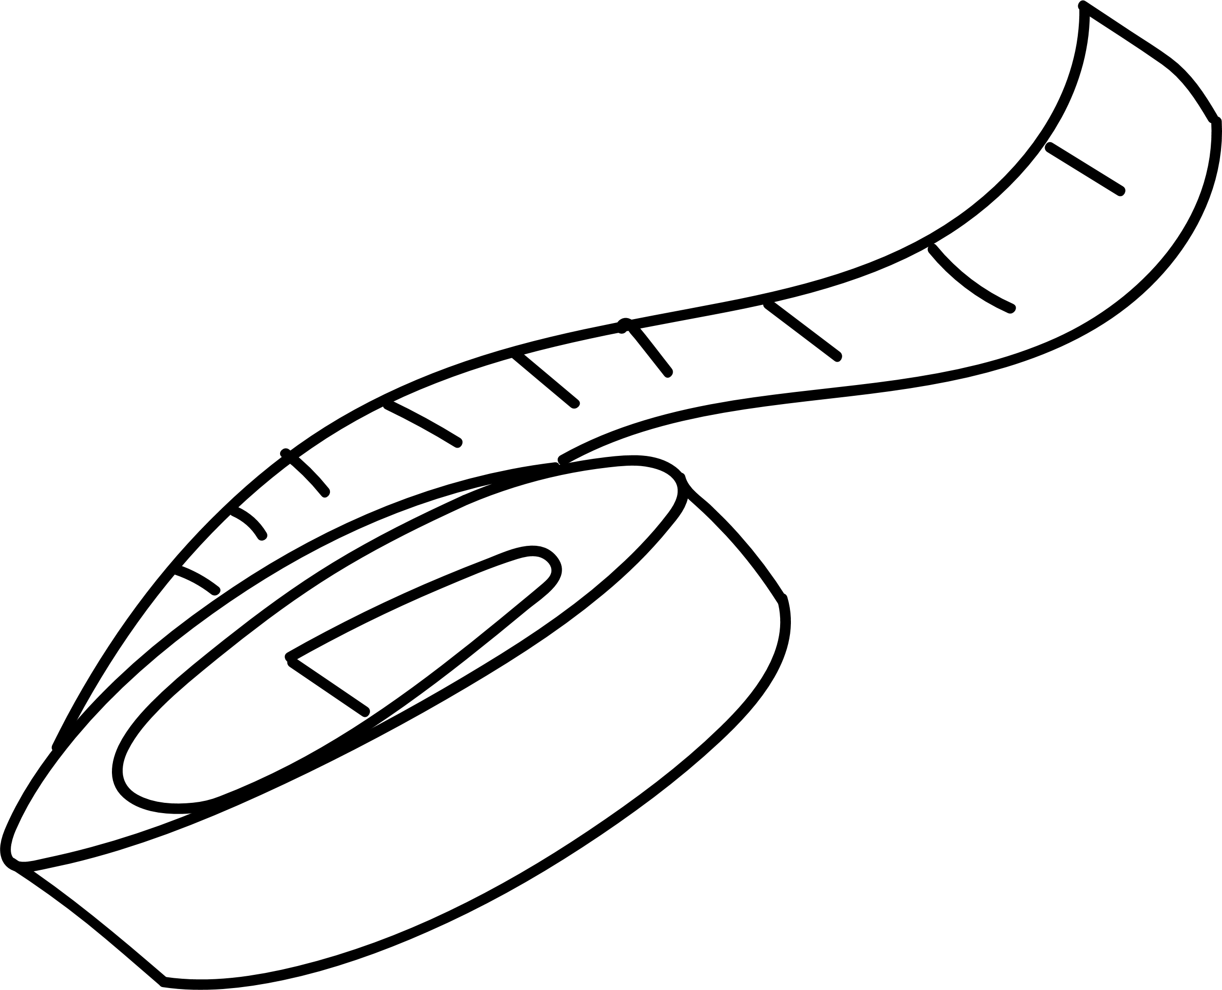

20XX



NUTRICIÓN  
DIARIO DE

Lorem Ipsum Dolor



# Aperitivos saludables Ideas



|  |  |  |  |  |  |  |  |  |  |  |
| --- | --- | --- | --- | --- | --- | --- | --- | --- | --- | --- |
|  | Frutos secos |  |  |  | Verduras |  |  |  | Fruta |  |
|  |  |  |  |  |  |  |
|  | | |  |  | | |  |  | | |
|  | | |  | | |  |  |  |  |
|  | | |  | | |  |  | | |
|  |  |  |  | | |  |  | | |
|  |  |  |  |  |  |  |  |  |  |
|  | Mariscos |  |  |  | Pescado |  |  |  | Dulce |  |
|  |  |  |  |  |  |  |  |
|  | | |  |  | | |  |  | | |
|  | | |  |  | | |  |  | | |
|  | | |  |  |  |  |  |  | | |
|  | | |  |  |  |  |  |  |  |  |
|  |  |  |  |  |  |  |  |  |  |  |

|  |  |  |
| --- | --- | --- |
|  | Otros |  |
|  |  |
|  | | |
|  | | |
|  | | |

# Registro de comidas semanal



|  |  |  |  |  |  |
| --- | --- | --- | --- | --- | --- |
|  | Dom. |  | Lun. |  | Mar. |
|  |  |  |  |  |  |
|  |  |  |  |  |  |
|  |  |  |  |  |  |
|  |  |  |  |  |  |
|  |  |  |  |  |  |
|  |  |  |  |  |  |
|  | Mié. |  | Jue. |  | Notas |
|  |  |  |  |  |  |
|  |  |  |  |  |  |
|  |  |  |  |  |  |
|  |  |  |  |  |  |
|  |  |  |  |  |  |
|  |  |  |  |  |  |
|  | Vie. |  | Sáb. |  |  |
|  |  |  |  |
|  |  |  |  |  |  |
|  |  |  |  |  |  |
|  |  |  |  |  |  |
|  |  |  |  |  |  |
|  |  |  |  |  |  |

# Seguimiento de hidratación



## Mes

|  |  |  |  |
| --- | --- | --- | --- |
| 1 |  | 16 |  |
| 2 |  | 17 |  |
| 3 |  | 18 |  |
| 4 |  | 19 |  |
| 5 |  | 20 |  |
| 6 |  | 21 |  |
| 7 |  | 22 |  |
| 8 |  | 23 |  |
| 9 |  | 24 |  |
| 10 |  | 25 |  |
| 11 |  | 26 |  |
| 12 |  | 27 |  |
| 13 |  | 28 |  |
| 14 |  | 29 |  |
| 15 |  | 30 |  |

##### Seguimiento de peso



|  |  |  |  |  |  |  |  |  |  |  |  |  |
| --- | --- | --- | --- | --- | --- | --- | --- | --- | --- | --- | --- | --- |
|  | Ene | Feb | Mar | Abr | May | Jun | Jul | Ago | Sep | Oct | Nov | Dic |
| 50 |  |  |  |  |  |  |  |  |  |  |  |  |
| 49 |  |  |  |  |  |  |  |  |  |  |  |  |
| 48 |  |  |  |  |  |  |  |  |  |  |  |  |
| 47 |  |  |  |  |  |  |  |  |  |  |  |  |
| 46 |  |  |  |  |  |  |  |  |  |  |  |  |
| 45 |  |  |  |  |  |  |  |  |  |  |  |  |
| 44 |  |  |  |  |  |  |  |  |  |  |  |  |
| 43 |  |  |  |  |  |  |  |  |  |  |  |  |
| 42 |  |  |  |  |  |  |  |  |  |  |  |  |
| 41 |  |  |  |  |  |  |  |  |  |  |  |  |
| 40 |  |  |  |  |  |  |  |  |  |  |  |  |
| 39 |  |  |  |  |  |  |  |  |  |  |  |  |
| 38 |  |  |  |  |  |  |  |  |  |  |  |  |

##### Medidas



|  |  |  |  |  |  |  |
| --- | --- | --- | --- | --- | --- | --- |
|  | Ene | Mar | May | Jul | Sep | Nov |
| Pecho |  |  |  |  |  |  |
| Caderas |  |  |  |  |  |  |
| Muslo izquierdo |  |  |  |  |  |  |
| Muslo derecho |  |  |  |  |  |  |
| Brazo izquierdo |  |  |  |  |  |  |
| Brazo derecho |  |  |  |  |  |  |

# Premios saludables



|  |  |  |
| --- | --- | --- |
| Inicio |  | Fase 1 |
|  |
|  |
|  |  | Fase 3 |
| Fin |  |  |



|  |  |
| --- | --- |
|  | Fase 2 |
|  | Fase 4 |



# Objetivos de nutrición



|  |  |  |
| --- | --- | --- |
|  | Grupo de objetivos 1 |  |
|  |  |
|  | | |
|  | | |
|  | | |
|  | | |

|  |  |  |  |  |  |  |
| --- | --- | --- | --- | --- | --- | --- |
|  | Grupo de objetivos 2 |  |  |  | Grupo de objetivos 3 |  |
|  |  |  |  |
|  |  |  |  |  |  |  |
|  |  |  |  |  |  |  |
|  |  |  |  |  |  |  |
|  |  |  |  |  |  |  |
|  |  |  |  |  |  |  |

|  |  |  |
| --- | --- | --- |
|  | Grupo de objetivos 4 |  |
|  |  |
|  | | |
|  | | |
|  | | |
|  | | |