*El título o la descripción de las fotos pueden ir aquí.*

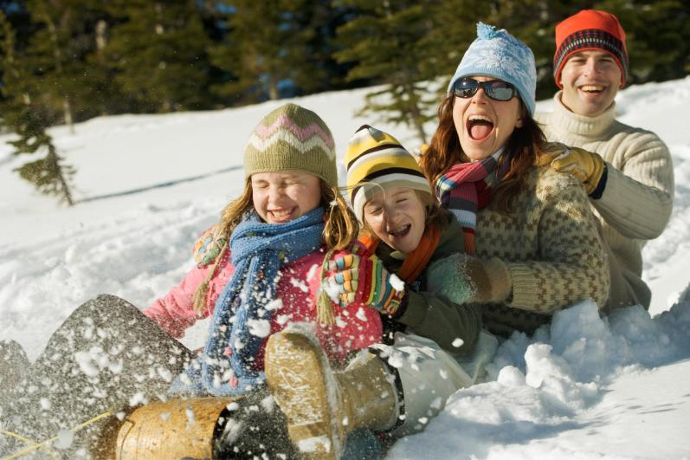

|  |  |  |  |  |  |  |
| --- | --- | --- | --- | --- | --- | --- |
| Enero 2008 | | | | | | |
| Lunes | Martes | Miércoles | Jueves | Viernes | Sábado | Domingo |
|  | 1 | 2 | 3 | 4 | 5 | 6 |
|  | Año Nuevo |  |  |  |  |  |
| 7 | 8 | 9 | 10 | 11 | 12 | 13 |
|  |  |  |  |  |  |  |
| 14 | 15 | 16 | 17 | 18 | 19 | 20 |
|  |  |  |  |  |  |  |
| 21 | 22 | 23 | 24 | 25 | 26 | 27 |
| Día de Martín  Lutero King |  |  |  |  |  |  |
| 28 | 29 | 30 | 31 |  |  |  |
|  |  |  |  |  |  |  |
|  |  |  |  |  |  |  |
|  |  |  |  |  |  |  |

*El título o la descripción de las fotos pueden ir aquí.*

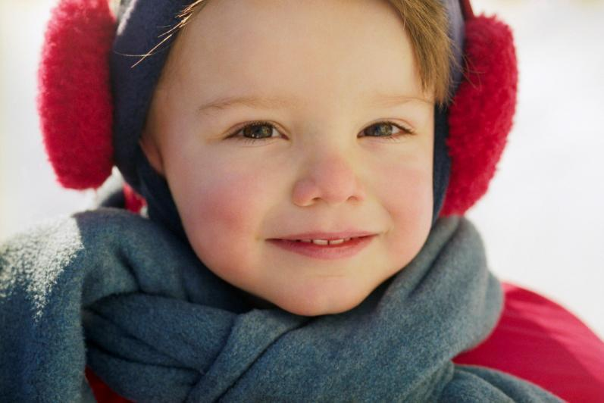

|  |  |  |  |  |  |  |
| --- | --- | --- | --- | --- | --- | --- |
| Febrero 2008 | | | | | | |
| LUNES | MARTES | MIÉRCOLES | JUEVES | VIERNES | SÁBADO | DOMINGO |
|  |  |  |  | 1 | 2 | 3 |
|  |  |  |  |  |  |  |
| 4 | 5 | 6 | 7 | 8 | 9 | 10 |
|  |  |  |  |  |  |  |
| 11 | 12 | 13 | 14 | 15 | 16 | 17 |
|  |  |  |  |  |  |  |
| 18 | 19 | 20 | 21 | 22 | 23 | 24 |
| Día del Presidente |  |  |  |  |  |  |
| 25 | 26 | 27 | 28 | 29 |  |  |
|  |  |  |  |  |  |  |
|  |  |  |  |  |  |  |
|  |  |  |  |  |  |  |

*El título o la descripción de las fotos pueden ir aquí.*

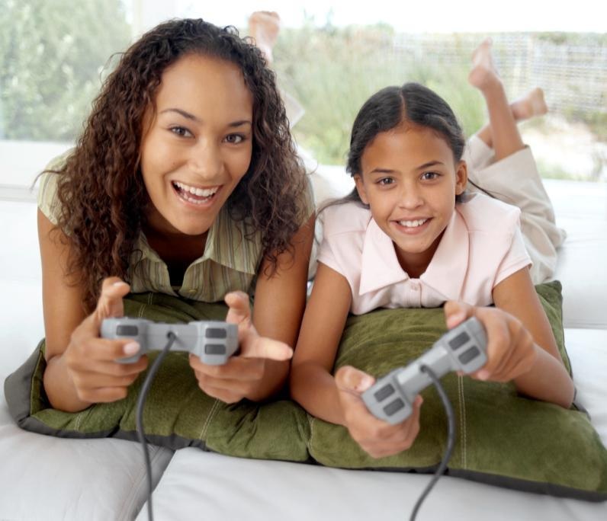

|  |  |  |  |  |  |  |
| --- | --- | --- | --- | --- | --- | --- |
| Marzo de 2008 | | | | | | |
| LUNES | MARTES | MIÉRCOLES | JUEVES | VIERNES | SÁBADO | DOMINGO |
|  |  |  |  |  | 1 | 2 |
|  |  |  |  |  |  |  |
| 3 | 4 | 5 | 6 | 7 | 8 | 9 |
|  |  |  |  |  |  |  |
| 10 | 11 | 12 | 13 | 14 | 15 | 16 |
|  |  |  |  |  |  |  |
| 17 | 18 | 19 | 20 | 21 | 22 | 23 |
|  |  |  |  |  |  |  |
| 24 | 25 | 26 | 27 | 28 | 29 | 30 |
|  |  |  |  |  |  |  |
| 31 |  |  |  |  |  |  |
|  |  |  |  |  |  |  |

*El título o la descripción de las fotos pueden ir aquí.*

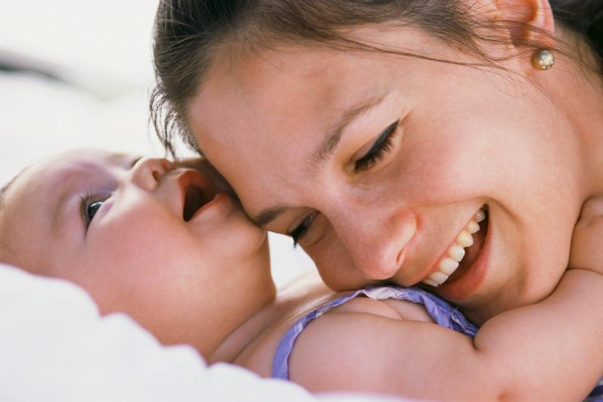

|  |  |  |  |  |  |  |
| --- | --- | --- | --- | --- | --- | --- |
| Abril 2008 | | | | | | |
| LUNES | MARTES | MIÉRCOLES | JUEVES | VIERNES | SÁBADO | DOMINGO |
|  | 1 | 2 | 3 | 4 | 5 | 6 |
|  |  |  |  |  |  |  |
| 7 | 8 | 9 | 10 | 11 | 12 | 13 |
|  |  |  |  |  |  |  |
| 14 | 15 | 16 | 17 | 18 | 19 | 20 |
|  |  |  |  |  |  |  |
| 21 | 22 | 23 | 24 | 25 | 26 | 27 |
|  |  |  |  |  |  |  |
| 28 | 29 | 30 |  |  |  |  |
|  |  |  |  |  |  |  |
|  |  |  |  |  |  |  |
|  |  |  |  |  |  |  |

*El título o la descripción de las fotos pueden ir aquí.*

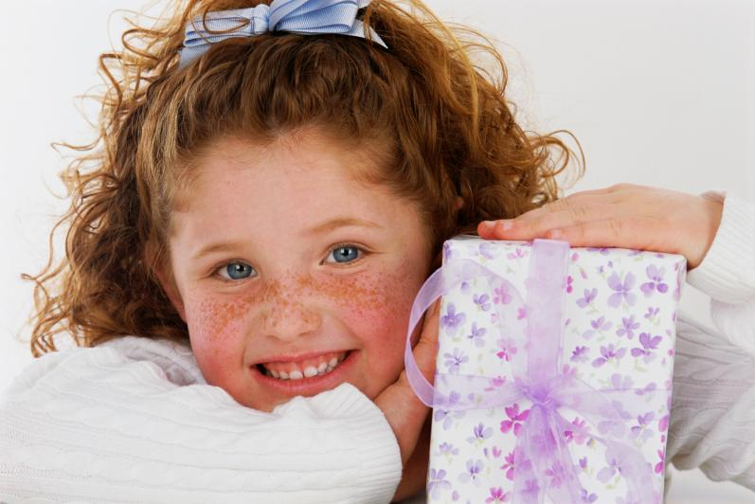

|  |  |  |  |  |  |  |
| --- | --- | --- | --- | --- | --- | --- |
| Mayo 2008 | | | | | | |
| LUNES | MARTES | MIÉRCOLES | JUEVES | VIERNES | SÁBADO | DOMINGO |
|  |  |  | 1 | 2 | 3 | 4 |
|  |  |  |  |  |  |  |
| 5 | 6 | 7 | 8 | 9 | 10 | 11 |
|  |  |  |  |  |  |  |
| 12 | 13 | 14 | 15 | 16 | 17 | 18 |
|  |  |  |  |  |  |  |
| 19 | 20 | 21 | 22 | 23 | 24 | 25 |
|  |  |  |  |  |  |  |
| 26 | 27 | 28 | 29 | 30 | 31 |  |
| Día de los Caídos |  |  |  |  |  |  |
|  |  |  |  |  |  |  |
|  |  |  |  |  |  |  |

*El título o la descripción de las fotos pueden ir aquí.*

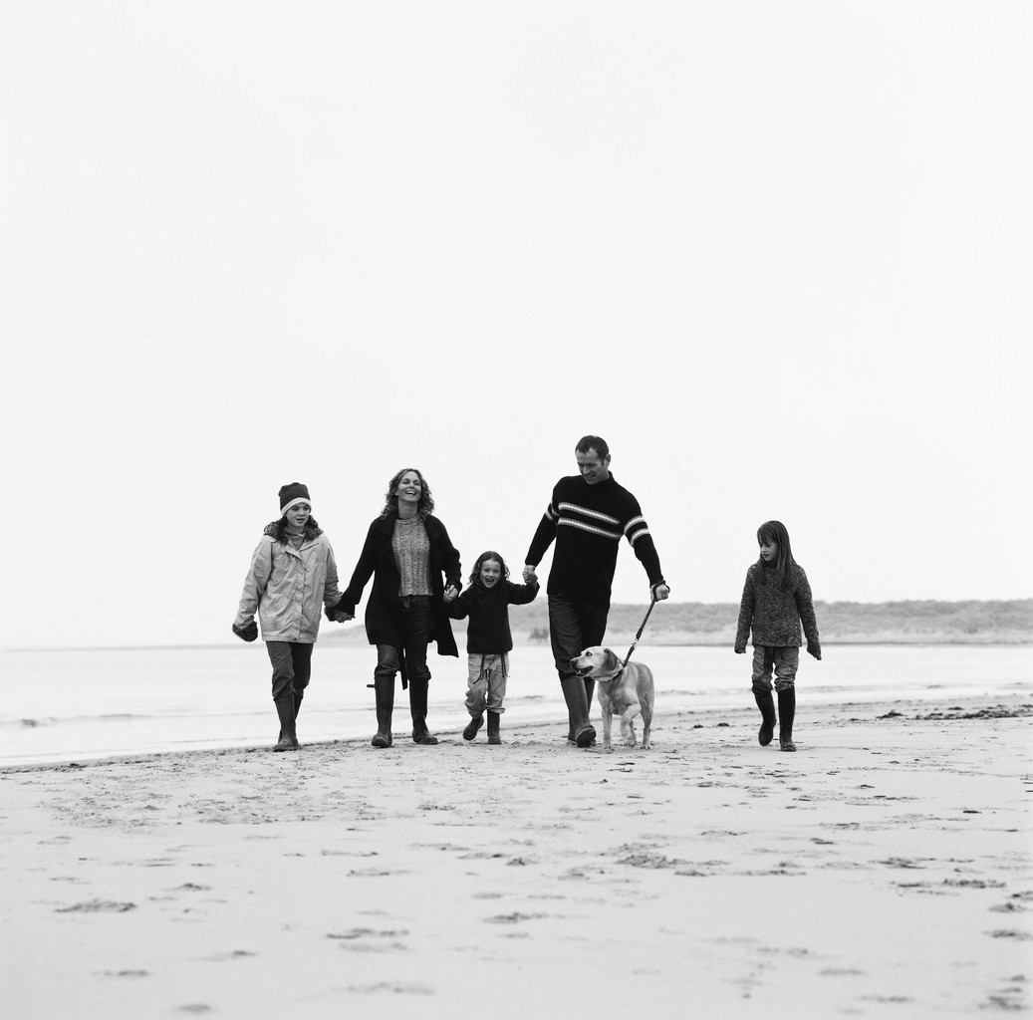

|  |  |  |  |  |  |  |
| --- | --- | --- | --- | --- | --- | --- |
| Junio 2008 | | | | | | |
| LUNES | MARTES | MIÉRCOLES | JUEVES | VIERNES | SÁBADO | DOMINGO |
|  |  |  |  |  |  | 1 |
|  |  |  |  |  |  |  |
| 2 | 3 | 4 | 5 | 6 | 7 | 8 |
|  |  |  |  |  |  |  |
| 9 | 10 | 11 | 12 | 13 | 14 | 15 |
|  |  |  |  |  |  |  |
| 16 | 17 | 18 | 19 | 20 | 21 | 22 |
|  |  |  |  |  |  |  |
| 23 | 24 | 25 | 26 | 27 | 28 | 29 |
|  |  |  |  |  |  |  |
| 30 |  |  |  |  |  |  |
|  |  |  |  |  |  |  |

*El título o la descripción de las fotos pueden ir aquí.*

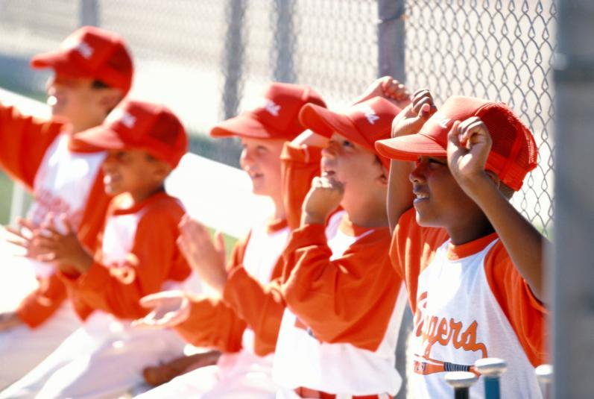

|  |  |  |  |  |  |  |
| --- | --- | --- | --- | --- | --- | --- |
| Julio 2008 | | | | | | |
| LUNES | MARTES | MIÉRCOLES | JUEVES | VIERNES | SÁBADO | DOMINGO |
|  | 1 | 2 | 3 | 4 | 5 | 6 |
|  |  |  |  | Descubrimiento de América |  |  |
| 7 | 8 | 9 | 10 | 11 | 12 | 13 |
|  |  |  |  |  |  |  |
| 14 | 15 | 16 | 17 | 18 | 19 | 20 |
|  |  |  |  |  |  |  |
| 21 | 22 | 23 | 24 | 25 | 26 | 27 |
|  |  |  |  |  |  |  |
| 28 | 29 | 30 | 31 |  |  |  |
|  |  |  |  |  |  |  |
|  |  |  |  |  |  |  |
|  |  |  |  |  |  |  |

*El título o la descripción de las fotos pueden ir aquí.*

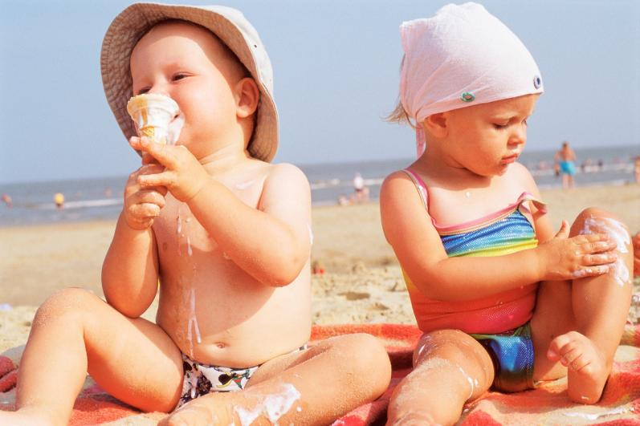

|  |  |  |  |  |  |  |
| --- | --- | --- | --- | --- | --- | --- |
| Agosto 2008 | | | | | | |
| LUNES | MARTES | MIÉRCOLES | JUEVES | VIERNES | SÁBADO | DOMINGO |
|  |  |  |  | 1 | 2 | 3 |
|  |  |  |  |  |  |  |
| 4 | 5 | 6 | 7 | 8 | 9 | 10 |
|  |  |  |  |  |  |  |
| 11 | 12 | 13 | 14 | 15 | 16 | 17 |
|  |  |  |  |  |  |  |
| 18 | 19 | 20 | 21 | 22 | 23 | 24 |
|  |  |  |  |  |  |  |
| 25 | 26 | 27 | 28 | 29 | 30 | 31 |
|  |  |  |  |  |  |  |
|  |  |  |  |  |  |  |
|  |  |  |  |  |  |  |

*El título o la descripción de las fotos pueden ir aquí.*

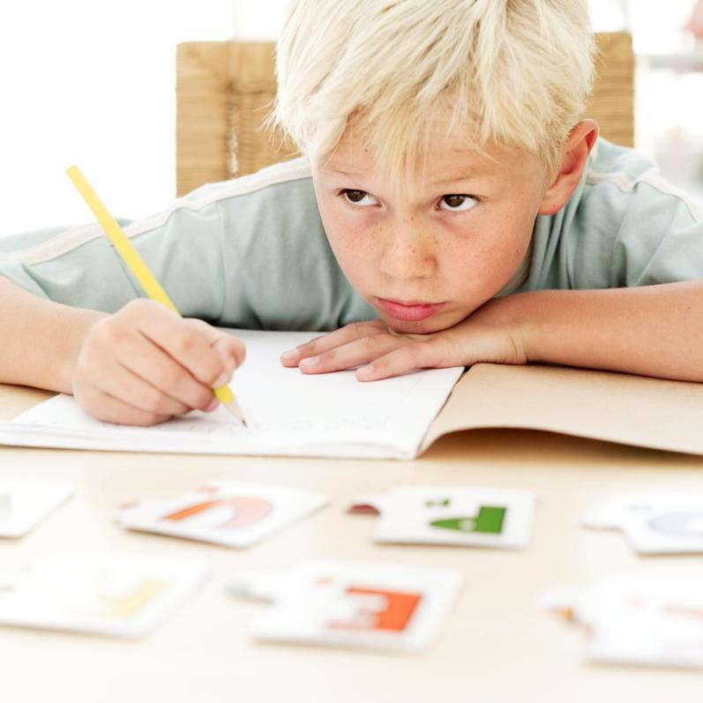

|  |  |  |  |  |  |  |
| --- | --- | --- | --- | --- | --- | --- |
| Septiembre 2008 | | | | | | |
| LUNES | MARTES | MIÉRCOLES | JUEVES | VIERNES | SÁBADO | DOMINGO |
| 1 | 2 | 3 | 4 | 5 | 6 | 7 |
| Día del Trabajo |  |  |  |  |  |  |
| 8 | 9 | 10 | 11 | 12 | 13 | 14 |
|  |  |  |  |  |  |  |
| 15 | 16 | 17 | 18 | 19 | 20 | 21 |
|  |  |  |  |  |  |  |
| 22 | 23 | 24 | 25 | 26 | 27 | 28 |
|  |  |  |  |  |  |  |
| 29 | 30 |  |  |  |  |  |
|  |  |  |  |  |  |  |
|  |  |  |  |  |  |  |
|  |  |  |  |  |  |  |

*El título o la descripción de las fotos pueden ir aquí.*

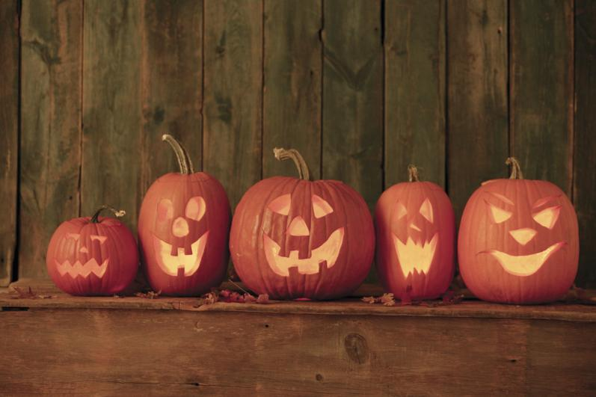

|  |  |  |  |  |  |  |
| --- | --- | --- | --- | --- | --- | --- |
| Octubre 2008 | | | | | | |
| LUNES | MARTES | MIÉRCOLES | JUEVES | VIERNES | SÁBADO | DOMINGO |
|  |  | 1 | 2 | 3 | 4 | 5 |
|  |  |  |  |  |  |  |
| 6 | 7 | 8 | 9 | 10 | 11 | 12 |
|  |  |  |  |  |  |  |
| 13 | 14 | 15 | 16 | 17 | 18 | 19 |
| Día de Colón |  |  |  |  |  |  |
| 20 | 21 | 22 | 23 | 24 | 25 | 26 |
|  |  |  |  |  |  |  |
| 27 | 28 | 29 | 30 | 31 |  |  |
|  |  |  |  |  |  |  |
|  |  |  |  |  |  |  |
|  |  |  |  |  |  |  |

*El título o la descripción de las fotos pueden ir aquí.*

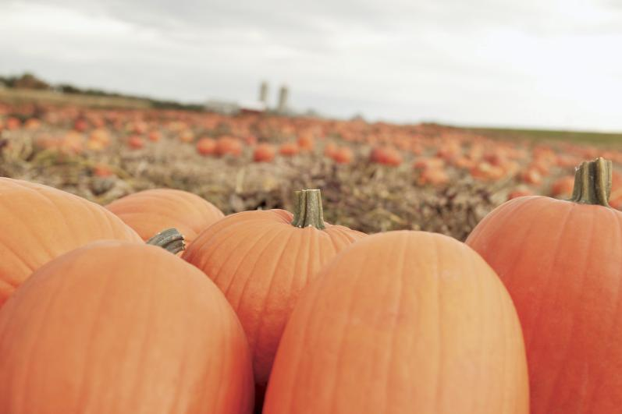

|  |  |  |  |  |  |  |
| --- | --- | --- | --- | --- | --- | --- |
| Noviembre 2008 | | | | | | |
| LUNES | MARTES | MIÉRCOLES | JUEVES | VIERNES | SÁBADO | DOMINGO |
|  |  |  |  |  | 1 | 2 |
|  |  |  |  |  |  |  |
| 3 | 4 | 5 | 6 | 7 | 8 | 9 |
|  |  |  |  |  |  |  |
| 10 | 11 | 12 | 13 | 14 | 15 | 16 |
|  | Día del Armisticio |  |  |  |  |  |
| 17 | 18 | 19 | 20 | 21 | 22 | 23 |
|  |  |  |  |  |  |  |
| 24 | 25 | 26 | 27 | 28 | 29 | 30 |
|  |  |  | Acción de Gracias |  |  |  |
|  |  |  |  |  |  |  |
|  |  |  |  |  |  |  |

*El título o la descripción de las fotos pueden ir aquí.*

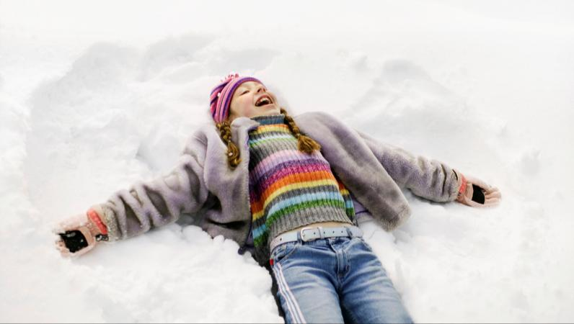

|  |  |  |  |  |  |  |
| --- | --- | --- | --- | --- | --- | --- |
| Diciembre 2008 | | | | | | |
| LUNES | MARTES | MIÉRCOLES | JUEVES | VIERNES | SÁBADO | DOMINGO |
| 1 | 2 | 3 | 4 | 5 | 6 | 7 |
|  |  |  |  |  |  |  |
| 8 | 9 | 10 | 11 | 12 | 13 | 14 |
|  |  |  |  |  |  |  |
| 15 | 16 | 17 | 18 | 19 | 20 | 21 |
|  |  |  |  |  |  |  |
| 22 | 23 | 24 | 25 | 26 | 27 | 28 |
|  |  |  | Navidad |  |  |  |
| 29 | 30 | 31 |  |  |  |  |
|  |  |  |  |  |  |  |
|  |  |  |  |  |  |  |
|  |  |  |  |  |  |  |