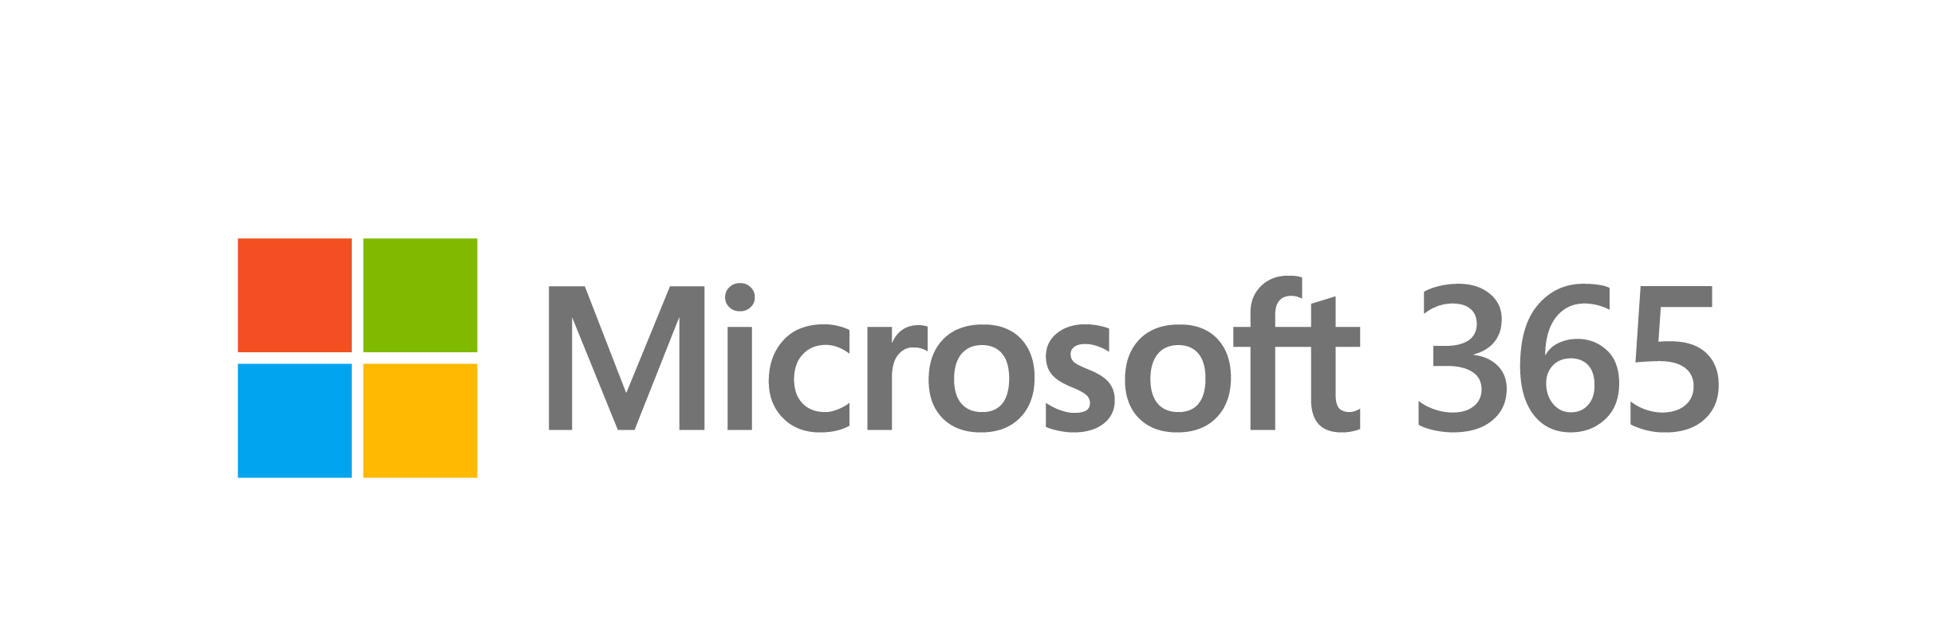

Bring out your best writing with Editor
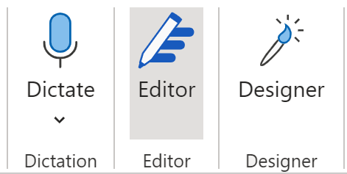 | Microsoft Editor helps you write with confidence by offering suggestions to strengthen your spelling, grammar, and style. Here in Word, you can tell Editor is running because the Editor pane is open.  You can open it anytime by selecting the Editor icon near the top of the window (Home tab):
Try it: Wherever you see an underllined word or phrase in this document, select it to see the suggestion.

Wait, is Editor new?
Spelling and grammar checking have been in Word for a long time, but Editor ups the game with suggestions to refine your writing for clarity, conciseness, and more.
Note: Spelling and basic grammar checking are available for free—all other features require a Microsoft 365 subscription.
Try it: You can get down to brass tacks by selecting the underlined cliché.

Multi-language checking
Editor checks your writing in over twenty languages and offers spelling suggestions in over eighty!
Try it: You can say adois to this feaux pas by selecting the underlined words.

Similarity checking
Editor can also compare your words to online content to help you make sure your writing is original—or help you cite sources when you quote someone. | 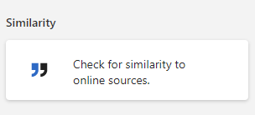
Try it: In Editor on the right, find the Similarity section and click Check for similarity to online sources. Notice how Editor makes it easy to add a citation for the following sentence:
The similarity checker shows you how much content in your document is original, and it makes it easy to insert citations when necessary.

Document stats
If you are using Word on the web, Editor shows you the word count, how easy it is to read your doc, and how long it will take for someone to read it.
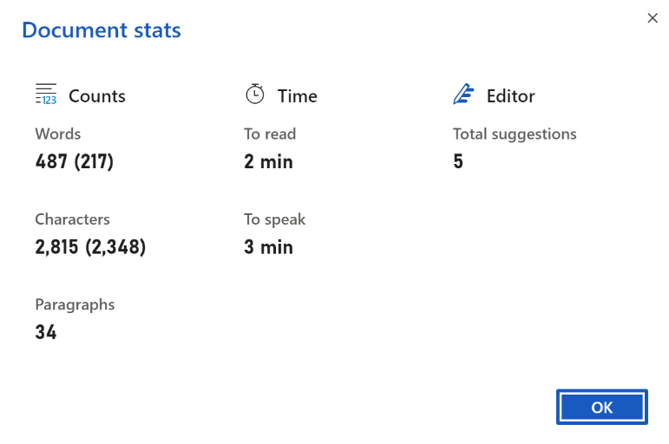
Try it in Word on the web: Get insights about the writing in this doc by scrolling down in the Editor panel to Insights and clicking Document stats. See if we made this doc a quick read.

And more…
Editor can also help you with clarity, formality, inclusiveness, punctuation, and sensitive geopolitical references.
Try it: Look at the suggestions Editor makes for the following sentences:
I did not see nothing.
We’d need to get a good cross-section of our customers – business users as well as consumers.
In recent years the technology has improved drastically.
The company is considering an office for Henan province in Cheng-chou, China.
By flying drones, indigenous rangers gather data to manage natural resources in Australia.

Ready, set, go!
Want to take a spin in a document of your own? Start a new Word document here, share it with your friends, and start writing.

Even use Editor on the web
Just download the Editor browser extension for Chrome or Edge, and use Editor whenever you post to social media or write in your web browser. Here is how to check grammar and spelling with the Microsoft Editor browser extension.

