

|  |
| --- |
| JOIN US FOR A |
|  |
| Menorah |
|  |
| HANUKKAH CELEBRATION |
| Decorative white star border |
| DECEMBER 12 20XX 7 PM |
| Celebrate Hanukkah with friends,  food, and more. |
|  |
| 345 MAIN STREET |



|  |
| --- |
| JOIN US FOR A |
| Hanukkah Celebration |
|  |
| Menorah |
|  |
| DECEMBER 12 20XX 7 PM |
|  |
| Celebrate Hanukkah with friends,  food, and more. |
| Decorative yellow star border |
| 345 MAIN STREET |

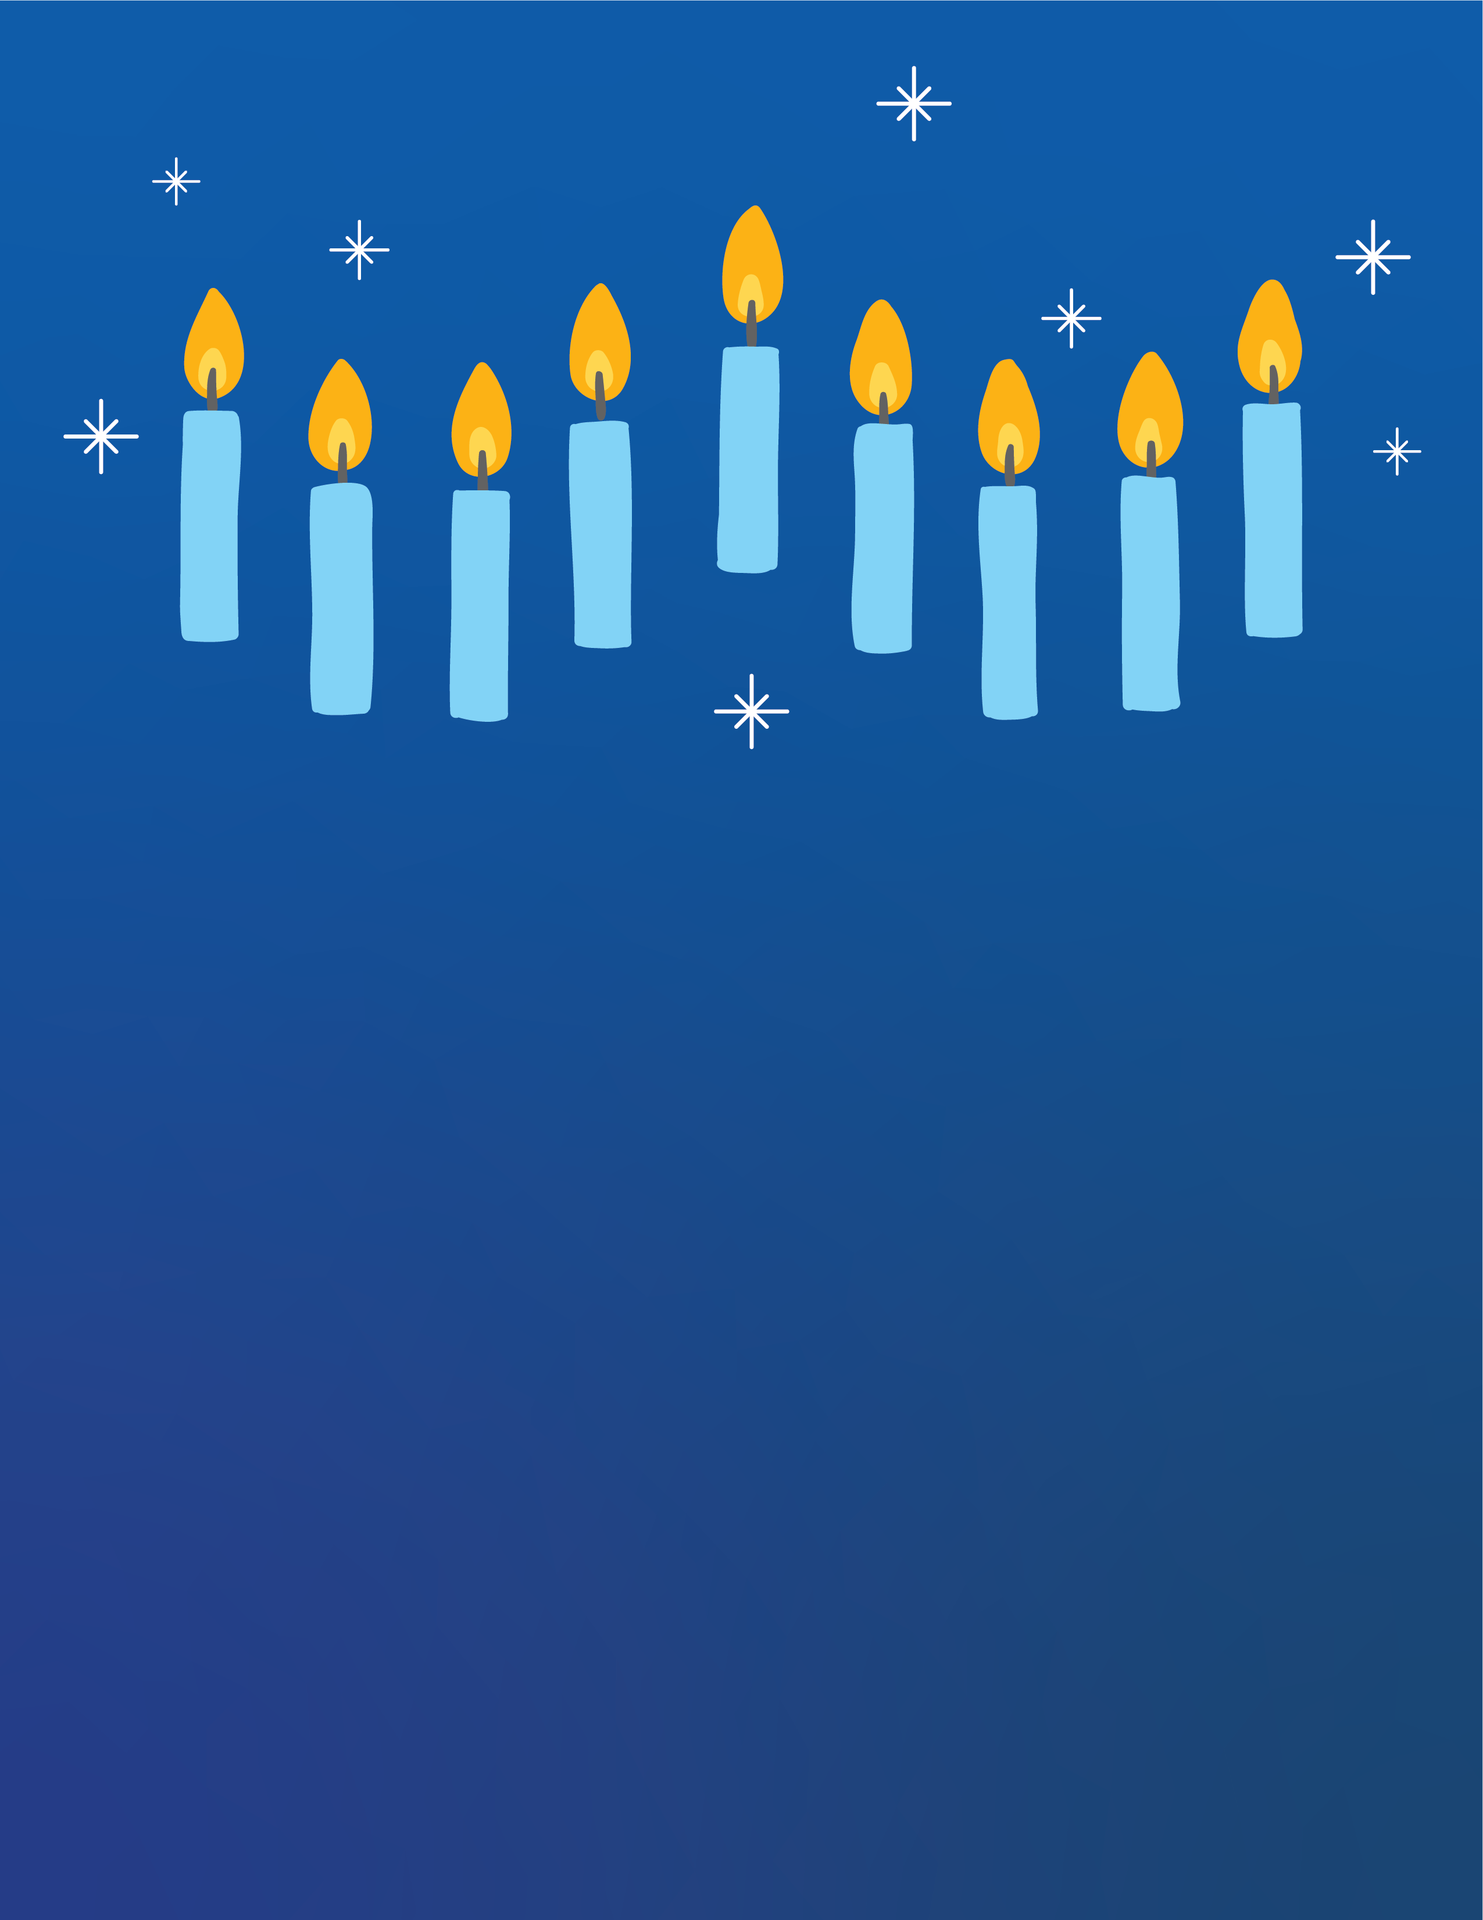

|  |
| --- |
| JOIN US FOR A |
|  |
| HANUKKAH CELEBRATION |
|  |
| Celebrate Hanukkah with friends,  food, and more. |
| Decorative white star border |
| DECEMBER 12 20XX 7 PM |
|  |
| 345 MAIN STREET |