Review and annotate with ink
  - Inking in Word
Want to learn how your pen simplifies your life? We’re here to help. To practice using ink features, look for Try it throughout this document.

Get familiar with your pen
Favorite uses:
- Digitally edit your documents
- Sign documents without a printer
- Quickly jot down notes in the margins
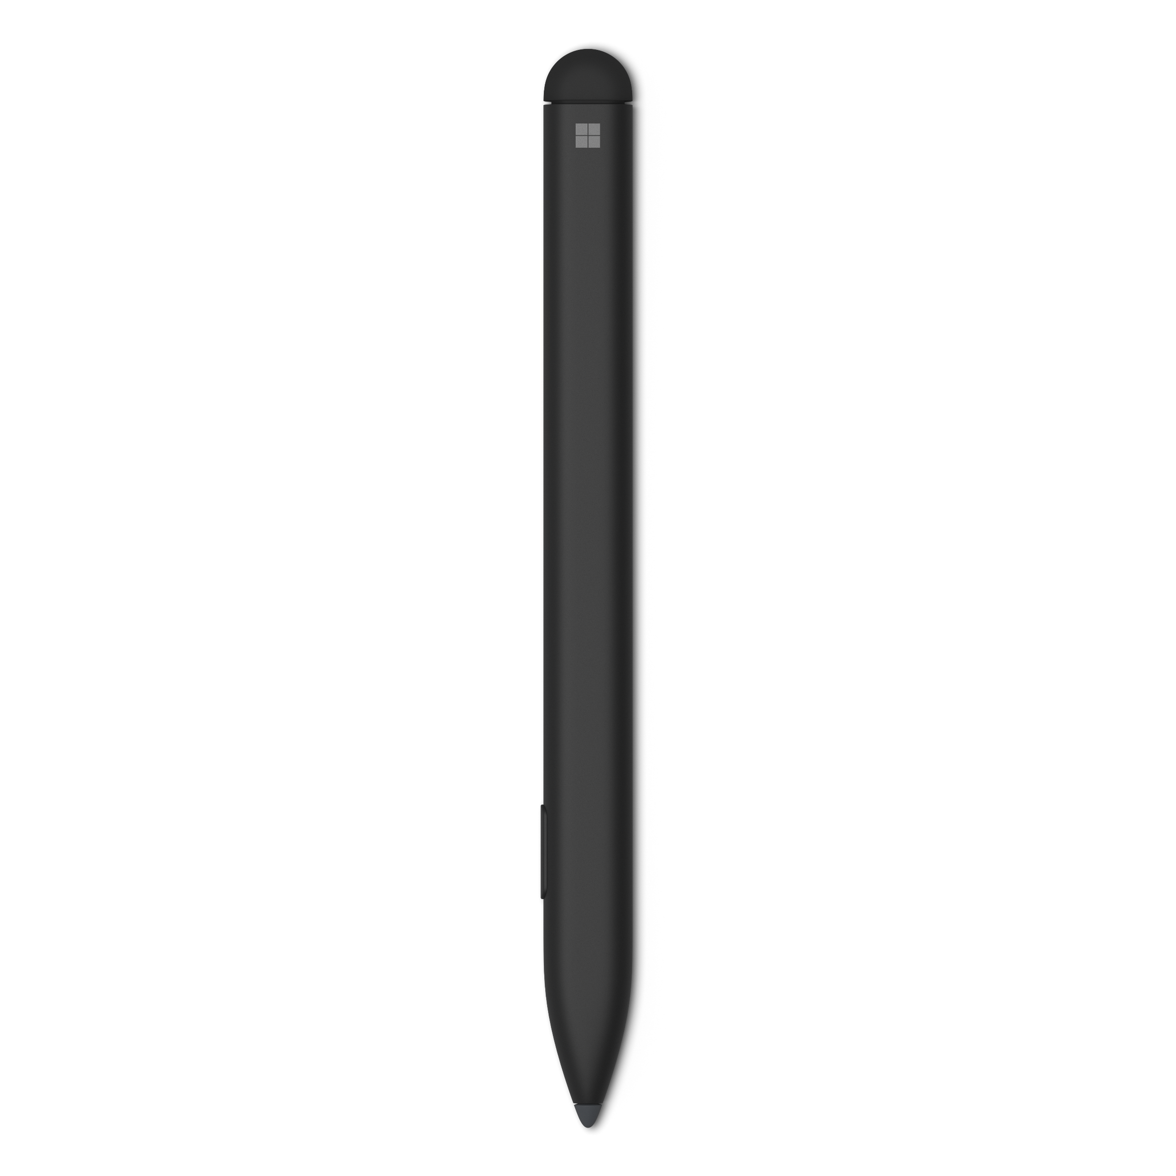
- Mark up documents as you read to remember information better

Flip your pen upside down and use the end to Erase any ink.
To Lasso ink, press and hold the barrel button, touch your pen to the screen and draw around the ink you wish to select.

Select the Draw tab to get started.
Try it: Get comfortable with your pen! Pick your favorite color, then use your pen to scribble in this space!

Annotate with ink
Try it: Complete these tasks in the sample paragraph to discover the hidden phrase.
- Underline the words learning, but, and flying.
- Place a circle around the phrase is not and the word fly.
- Highlight the words to, is, and pretty.

Pro Tip: Tap on the highlighter to see additional color options and features, like Snap to text.
Are you ready for some learning on how to save time and the environment with this new pen? This tutorial will fly by- we promise it is not a waste of your time! First, know this document shouldn’t look pretty by the time you’ve read through it. But instead, you should practice inking on the margins and scribbling around. We want you flying out of your chair with excitement over your new pen! We hope this pen is a tool that you’ll love and use frequently.

Try it: Use a galaxy colored pen to handwrite the marked words from the section above in the order they appeared on the paragraph.

Next, select the Eraser in the Draw Tab or use the back of your pen to uncover the answer below:
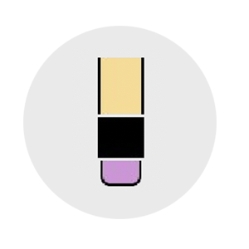
Learning to fly is not pretty but flying is. -Satya Nadella

Review with ink
Try it: Select the Action pen in the Draw Tab. Let’s see how you can edit faster than ever before!
- Practice deleting some words. Scribble with the pen over this sentence.
- Circling text is a fast way to select text to change it to bold, italic, etc. Can you bold this sentence with a pen?
- Quickly want to insert a word? Draw a caret to add any word to this sentence.

Pro tip: Refer to Ink Gesture Help in the action pen drop down for supported action pen gestures.

More questions about ink?
Type what you want to know into the Search bar.
See this guide for available ink features
Give us feedback on this template

