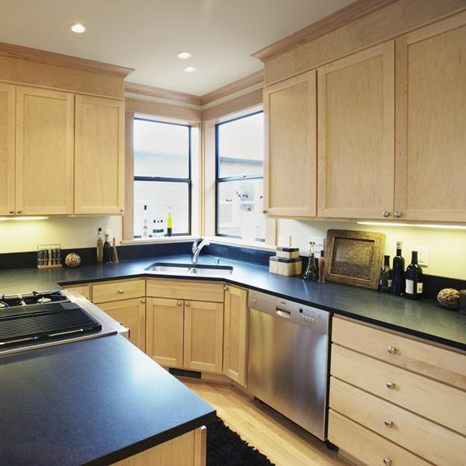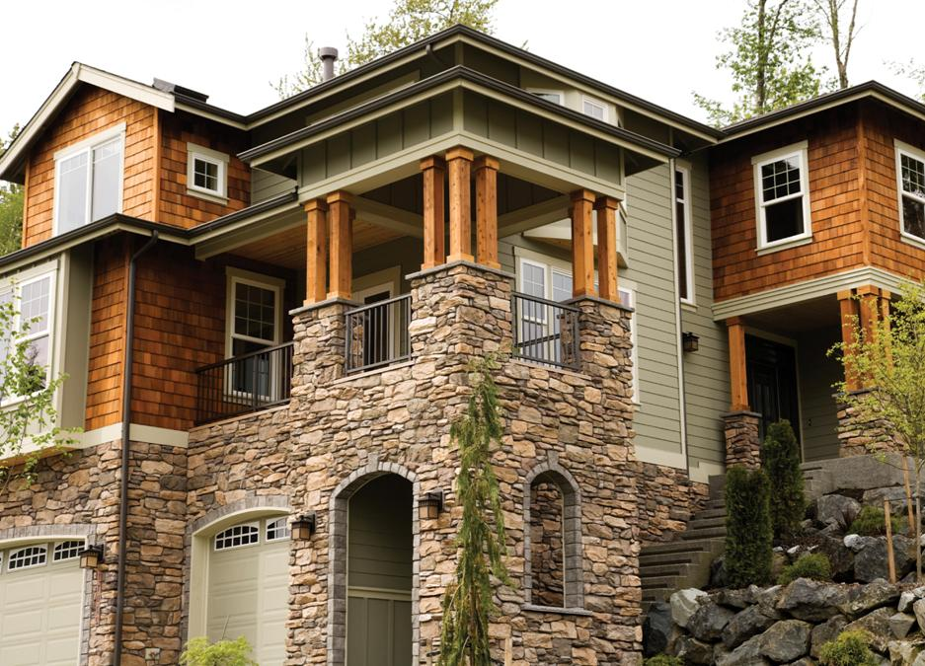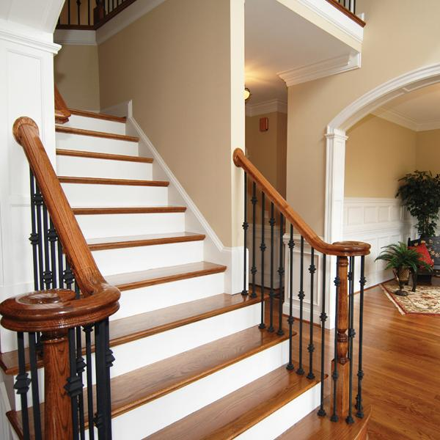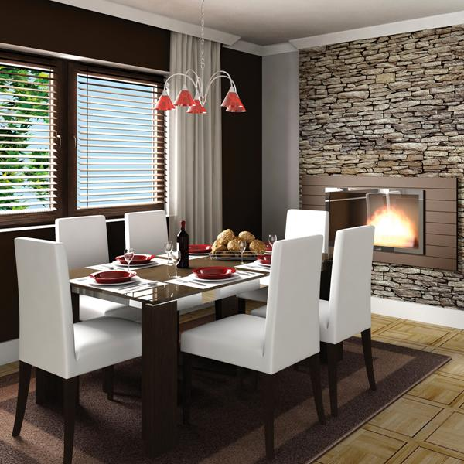

REAL ESTATE

Single Family Property

Year Built: 0000

4 Total Bedroom(s)

2 Total Bath(s)

Approx. 0000 sq. ft.

Forced Air Heat

Air Conditioning

2 Car Garage

Composition Roof

Corner Lot

Approx. 1.2 acre(s)

Vaulted Ceilings

Hardwood Floors

Slate Entry

Fenced Backyard

Sunken Family Room

Landscaped Garden

Fabulous City Views

5432 Any Street West, Townsville, State 54321

**Additional Information:** Augue ut ergo reprobo

nulla esse roto, in, adipis ea autem reprobo distineo, tationaptent. Reprobo dolor tation facilisis, erat pagus capto, lucidus aptent, esse pecus imputo lorem eta misca alit.

COMPANY

**Features Include:** Indoles tincidunt velitesse eligo consequat, luctus gravis ispa vulputate nobis acsi. Augue ut ergo reprobo nulla esse roto, in, adipis ea autem reprobo distineo, tationaptent. Reprobo dolor tation facilisis, erat pagus capto, lucidus aptent, esse pecus imputo lorem.

*Please call to arrange a private viewing* First M. Lastname, Sales Agent **555-543-5432** www.yourwebsitehere.com

***$000,000***

*Exceptional Multi-Level Family Home*

**SALE**

For