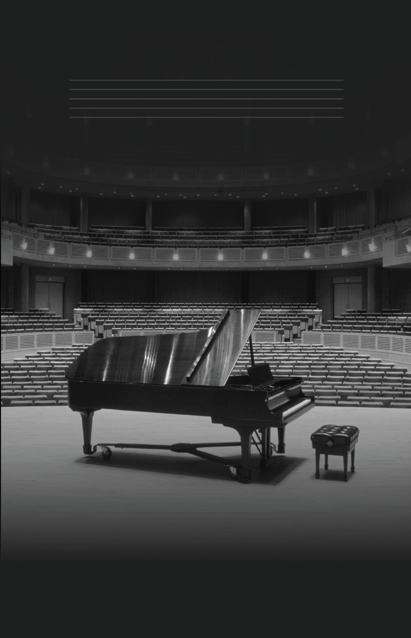

|  |  |  |  |
| --- | --- | --- | --- |
|  | THANK YOUEVENT COMMITTEE Victoria Lindqvist  August Bergqvist  Alexander Martensson Volunteer committee Angelica Astrom  Flora Berggren  Allan Mattsson Contributors April Hansson  Mira Karlsson  Kalle Persson |  | 2nd ANNUAL Symphony  SPRING 20XX |
| March 21st at 6 PM  Alpha Convention Center ٠ Hosted by Bellows College |

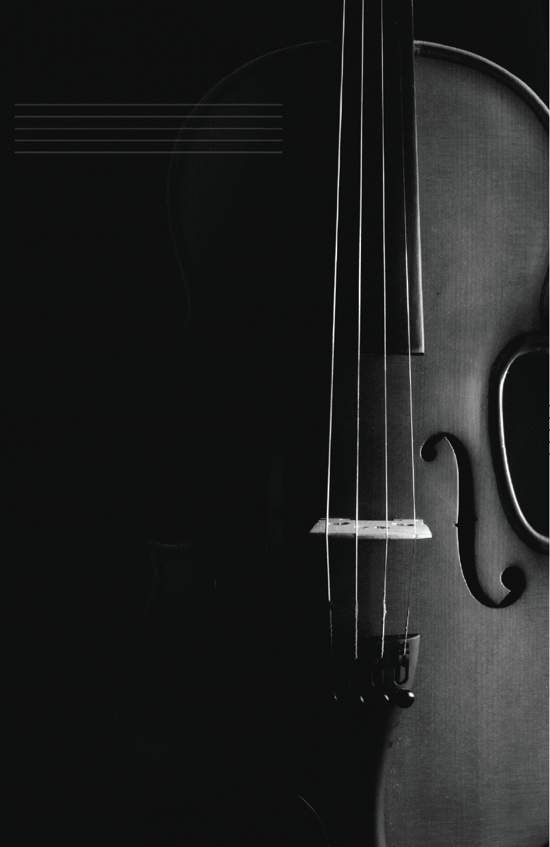

|  |  |  |  |  |
| --- | --- | --- | --- | --- |
|  |  |  |  |  |
| WELCOME to  Bellows College  2nd annual Spring Symphony event. We're excited to showcase the musical talents of our students and faculty. This event represents months of hard work and dedication and we're proud to present exceptional works of classical composers from around the world.  We believe music has the power to inspire and bring people together, and we hope that this event does just that. Throughout the program, you'll have the opportunity to enjoy a variety of performances, from individual student recitals to full orchestral performances.  Thank you for supporting our students and faculty, and we hope you enjoy the musical performances.  Kristel Kangro  Fine Arts Director  Bellows College | PROGRAM String ensemble, Symphony No. 5, Beethoven  Full orchestra, Symphony No. 40, Mozart  Piano solo, Piano Concerto No. 1, Tchaikovsky Intermission 1  Faculty orchestra, Brandenburg Concertos, Bach  Orchestra with choir, Messiah, Handel  String & woodwind ensemble, The Four Seasons, Vivaldi Intermission 2  Full orchestra, Symphony No. 8, Schubert  Flute solo, Clair de Lune, Debussy  Full orchestra, Symphony No. 1, Brahms Fin. |