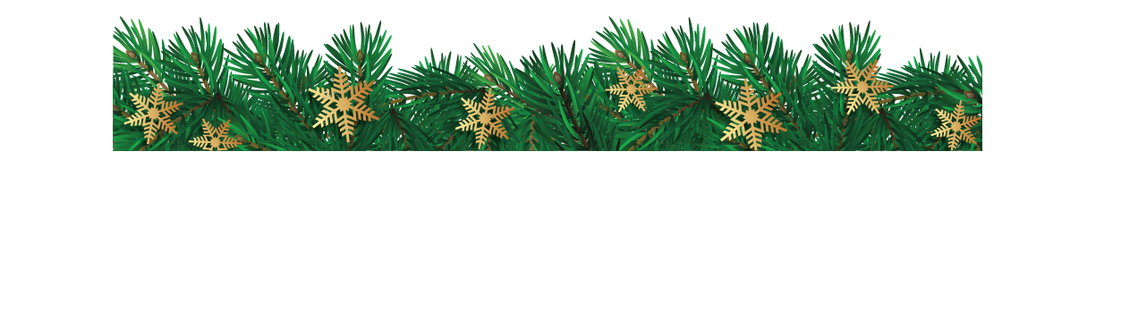

To replace this or any placeholder text with your own, just click it and start typing.

Want to update the images on the first page? Click on the image with your left side of your mouse until you see the selection handles around the picture. Do a right mouse click and choose Fill from the menu. Select Picture… from the fill options. Choose the location you wish to pull an image from, navigate to your desired image, and choose Insert.

To replace this or any placeholder text with your own, just click it and start typing.

Want to update the images on the first page? Click on the image with your left side of your mouse until you see the selection handles around the picture. Do a right mouse click and choose Fill from the menu. Select Picture… from the fill options. Choose the location you wish to pull an image from, navigate to your desired image, and choose Insert.