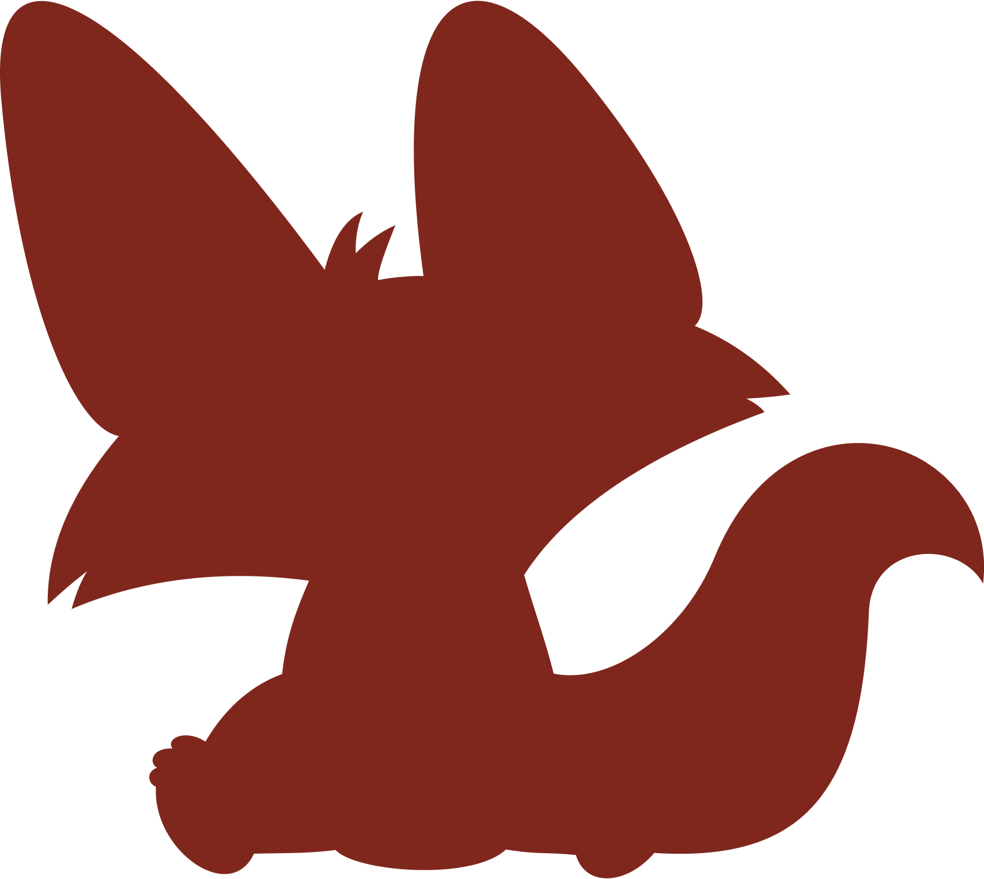

# PLEASE, JOIN Us FOR A

SIP & SEE PARTY

## BABY – COOKIES – DRINKS

|  |  |
| --- | --- |
| 25 july | 09:00 AM2345, Main St, Buffalo, NY Lorem ipsum dolor sit amet, consectetur adipiscingelit, sed do eiusmod tempor incididunt ut labore et dolore magna aliqua. |