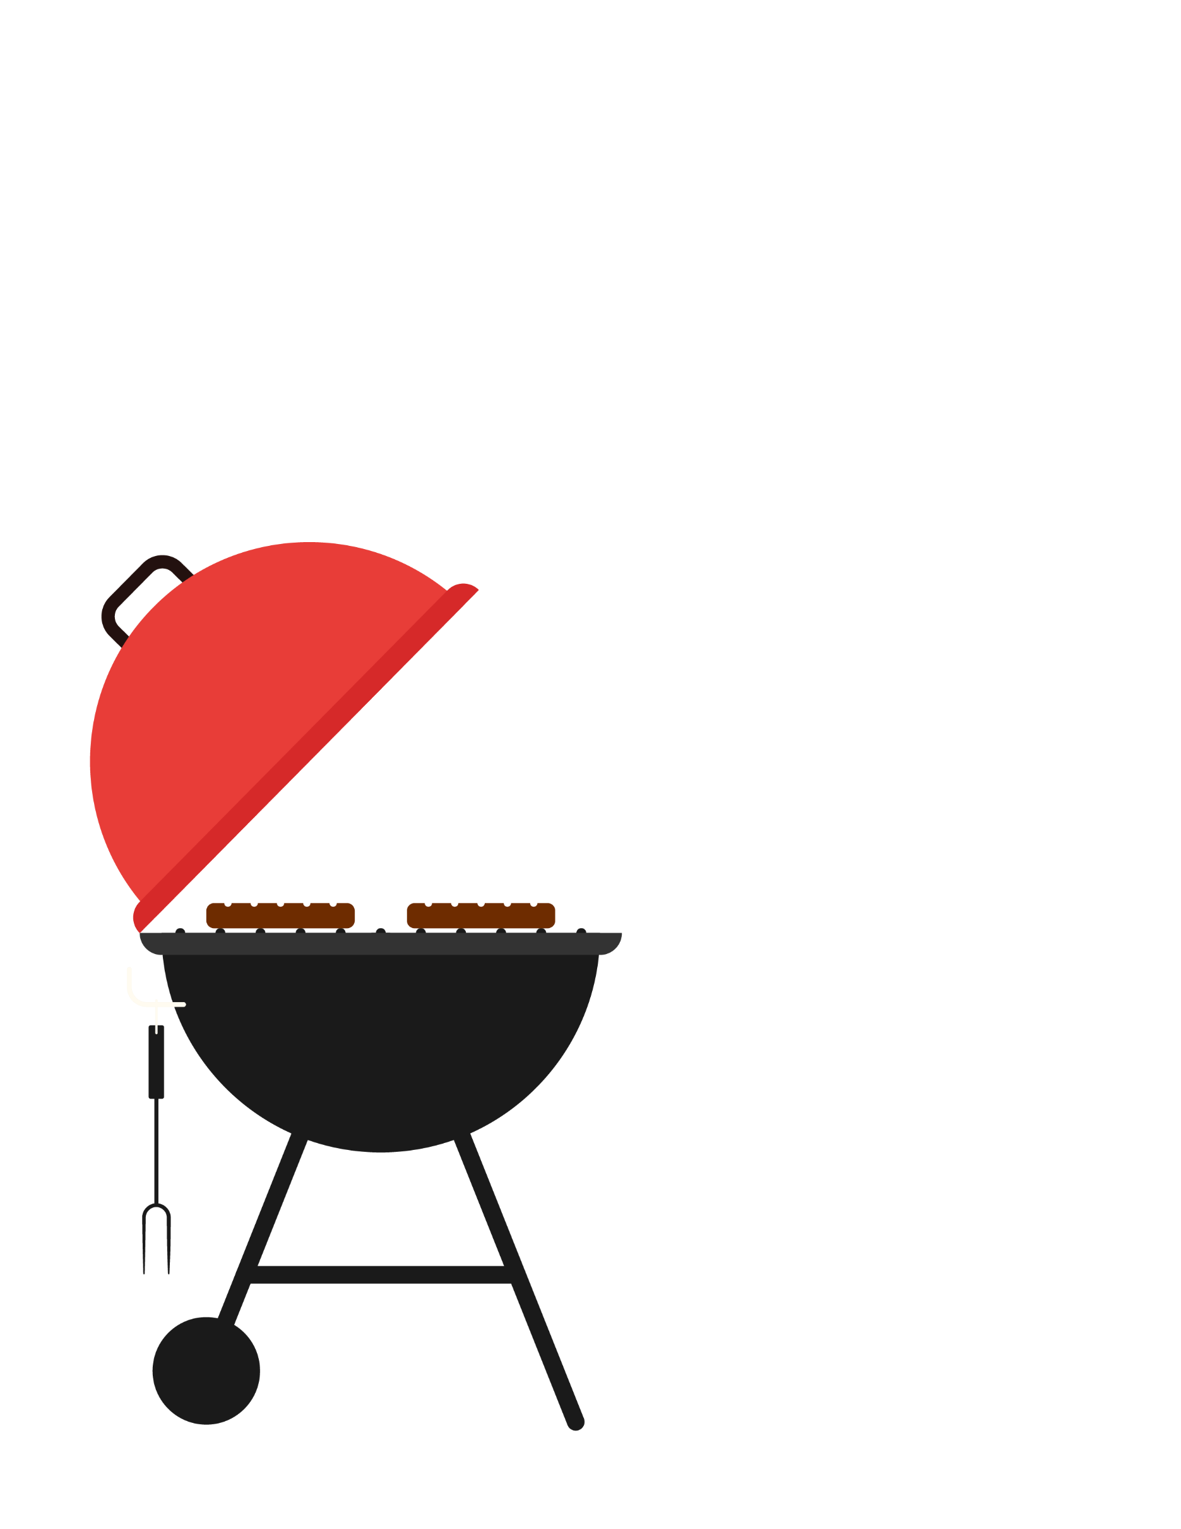

|  |
| --- |
| Memorial Day Barbeque |
| Monday, May 31, 20XX |
| 7:00PM • LAKESHORE PARK |
| CELEBRATE WITH FOOD, LIVE  MUSIC, GAMES, AND MORE |



|  |
| --- |
| Memorial Day Barbeque |
| Monday, May 31, 20XX 7:00PM • LAKESHORE PARK |
| CELEBRATE WITH FOOD, LIVE MUSIC, GAMES, AND MORE |



|  |
| --- |
| Memorial Day Barbeque |
| Monday, May 31, 20XX 7:00PM • LAKESHORE PARK |
| CELEBRATE WITH FOOD, LIVE MUSIC, GAMES, AND MORE |