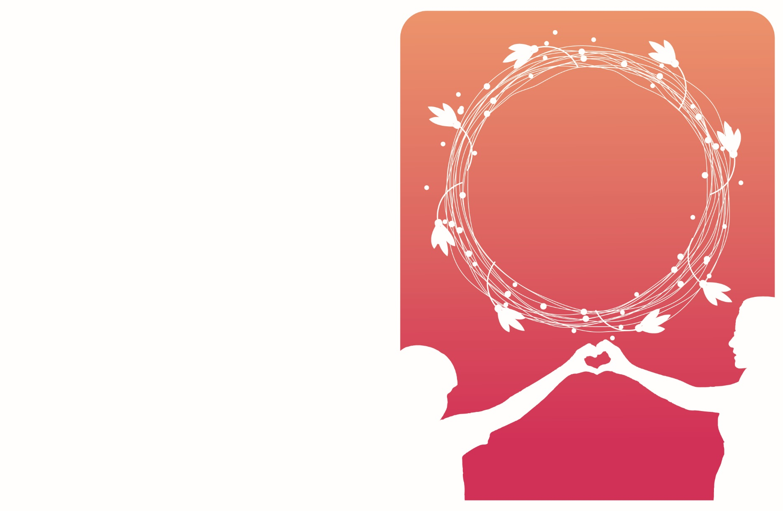

|  |  |
| --- | --- |
| HappyMother’sDay! |  |
|  | Most of all the other  beautiful things in life  come by twos and threes,  by dozens and hundreds  “But only one Mother  in the whole world.”  -Kate Douglas Wiggin |