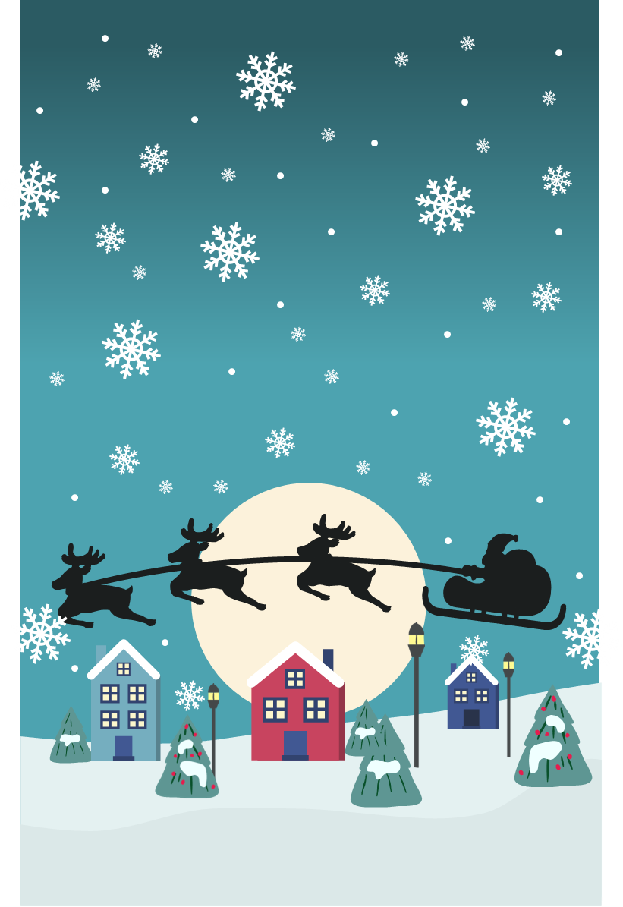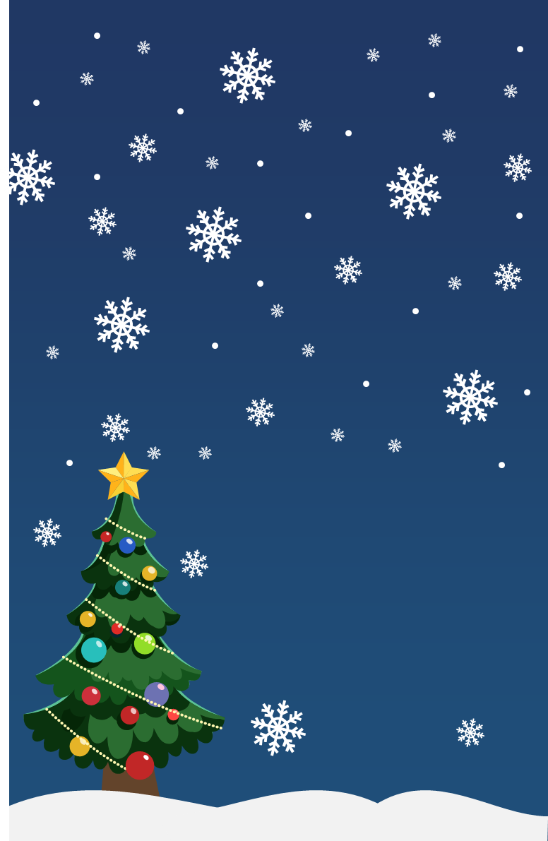

|  |  |
| --- | --- |
| MERRY CHRISTMAS | Merry Christmas |

|  |  |
| --- | --- |
| Best wishes for the happiest of holidays! | Best wishes for the happiest of holidays! |