|  |
| --- |
| Plenty of roses, stars, sunsets, rainbows, brothers, sisters, aunts and cousins... |
| Happy Mother's Day  But only one Mother in the whole world.   * KATE DOUGLAS WIGGIN |

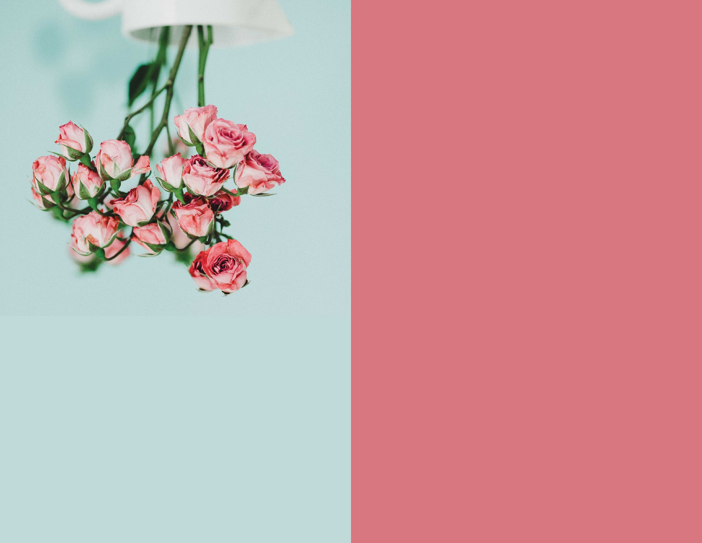

|  |
| --- |
| Most of all the other beautiful things in life come by twos and threes, by dozens and hundreads,,, |