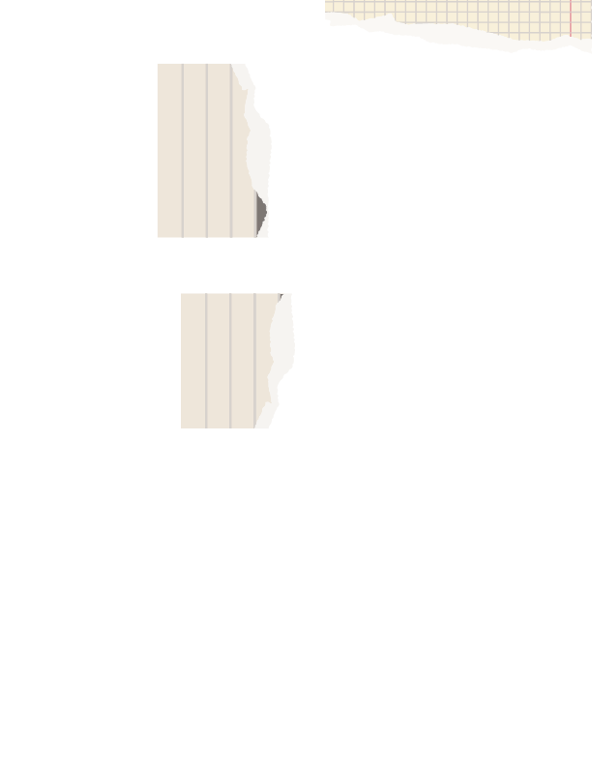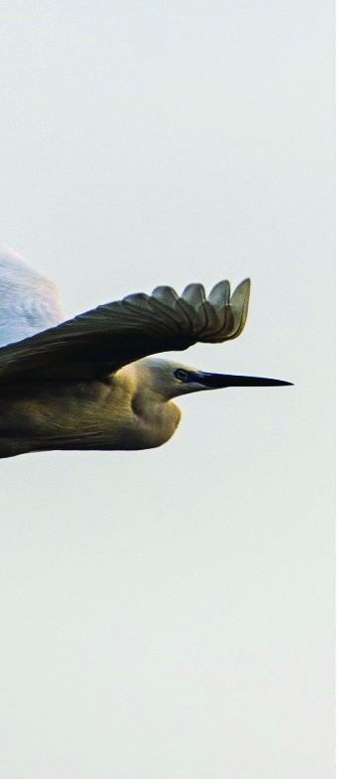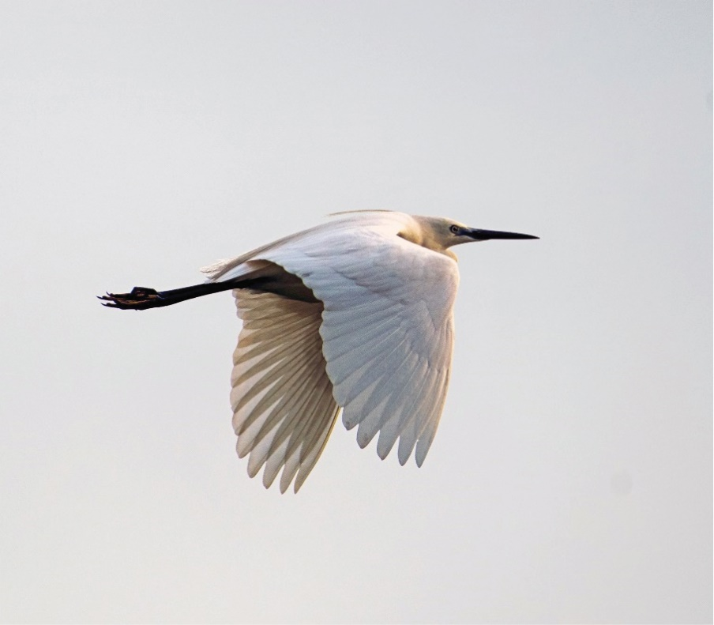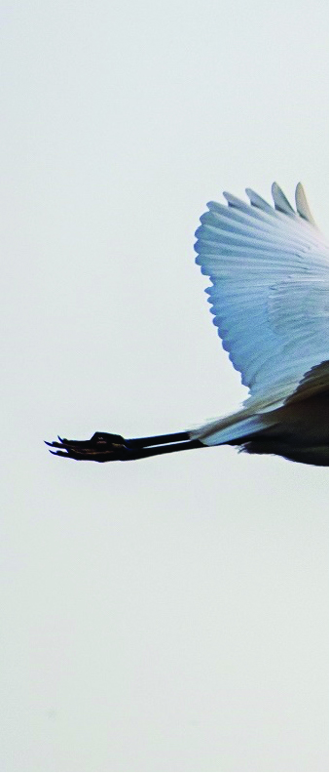

|  |  |  |  |
| --- | --- | --- | --- |
| 12 | | | |
| DEC 20XX | | | |
|  | | | |
|  | My travel  journal | | NATSUKI ITOBIRDWATCHING: A NEW ADVENTURE |
|  |  |  |  |
| Decorative |  | I never thoughtthat bird watchingwould becomemy new adventure,but here I am. | As a newbie to birdwatching, I was amazed  by the beauty and diversity of feathered  creatures I encountered in the wilderness.  The peacefulness of observing birds in their  natural habitat is an experience like no other.  I can't wait to continue exploring my new and exciting hobby. |