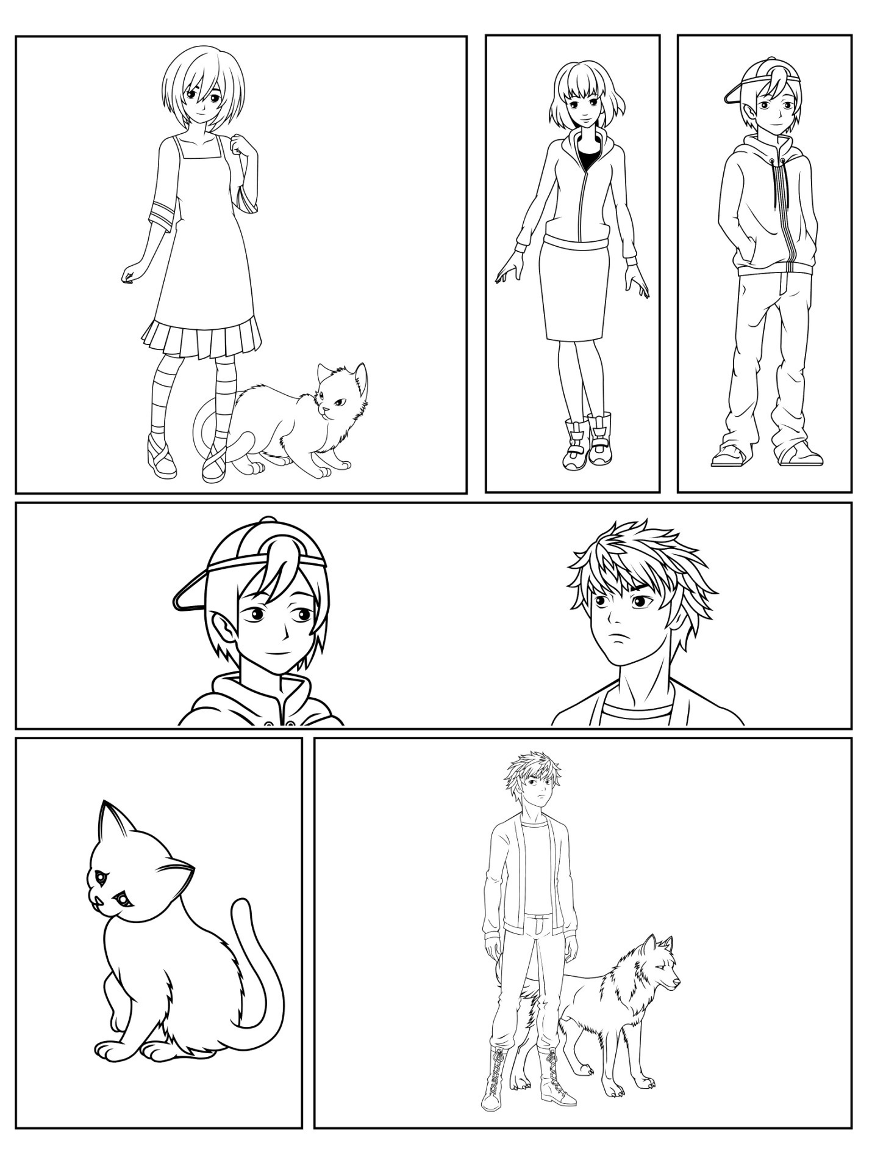

Additional overlap panels, text boxes, and speech and thought bubbles