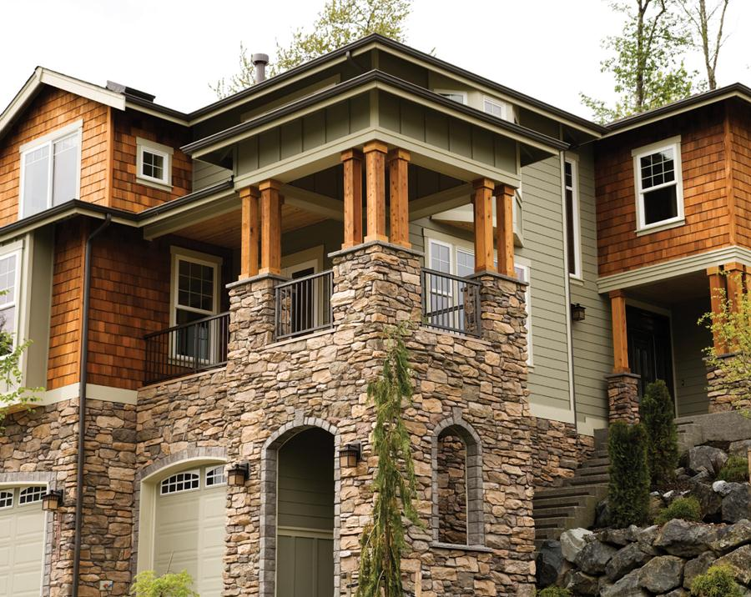

*Please Join Us for an Open House*

*Wednesday, 19 April from 14:00*

*456 Elm Road, Birmingham, West Midlands, B01 2HM*

*you’re*

***Invited***

*Please Join Us for an Open House*

*Wednesday, 19 April from 14:00*

*456 Elm Road, Birmingham, West Midlands, B01 2HM*

*you’re*

***Invited***

[](https://www.layoutready.com/?utm_source=microsoft&utm_medium=file&utm_campaign=office_online)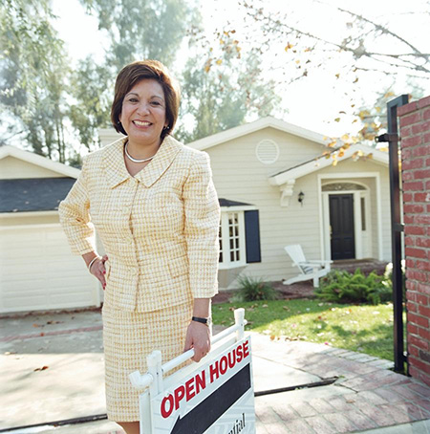

Single-family property

Year built: 0000

4 Total Bedroom(s)

2 Total Bath(s)

Approx 0000 sq. ft.

Forced air heat

***property details >>>***

*Exceptional multi-level family home*

First M. Surname, Estate Agent

COMPANY

REAL ESTATE

Contact us on **555 543 5432** www.yourwebsitehere.com

£*000,000*

Air conditioning

2-car garage

Composition roof

Corner plot

Approx 0.5 hectare(s)

Vaulted ceilings

Hardwood floors

Slate entry

Fenced garden

Sunken family room

Landscaped garden

Fabulous city views

Single-family property

Year built: 0000

4 Total Bedroom(s)

2 Total Bath(s)

Approx 0000 sq. ft.

Forced air heat

***property details >>>***

*Exceptional multi-level family home*

First M. Surname, Estate Agent

COMPANY

REAL ESTATE

Contact us on **555 543 5432** www.yourwebsitehere.com

£*000,000*

Air conditioning

2-car garage

Composition roof

Corner plot

Approx 0.5 hectare(s)

Vaulted ceilings

Hardwood floors

Slate entry

Fenced garden

Sunken family room

Landscaped garden

Fabulous city views