|  |
| --- |
|  |
| Save the date |
| 21 June 20XX |
| To share in the joy of  Bride and groom  As they are married |
| Couple holding hands |

|  |
| --- |
|  |
| Save the date |
| 21 June 20XX |
| To share in the joy of  Bride and groom  As they are married |
| Couple holding hands |

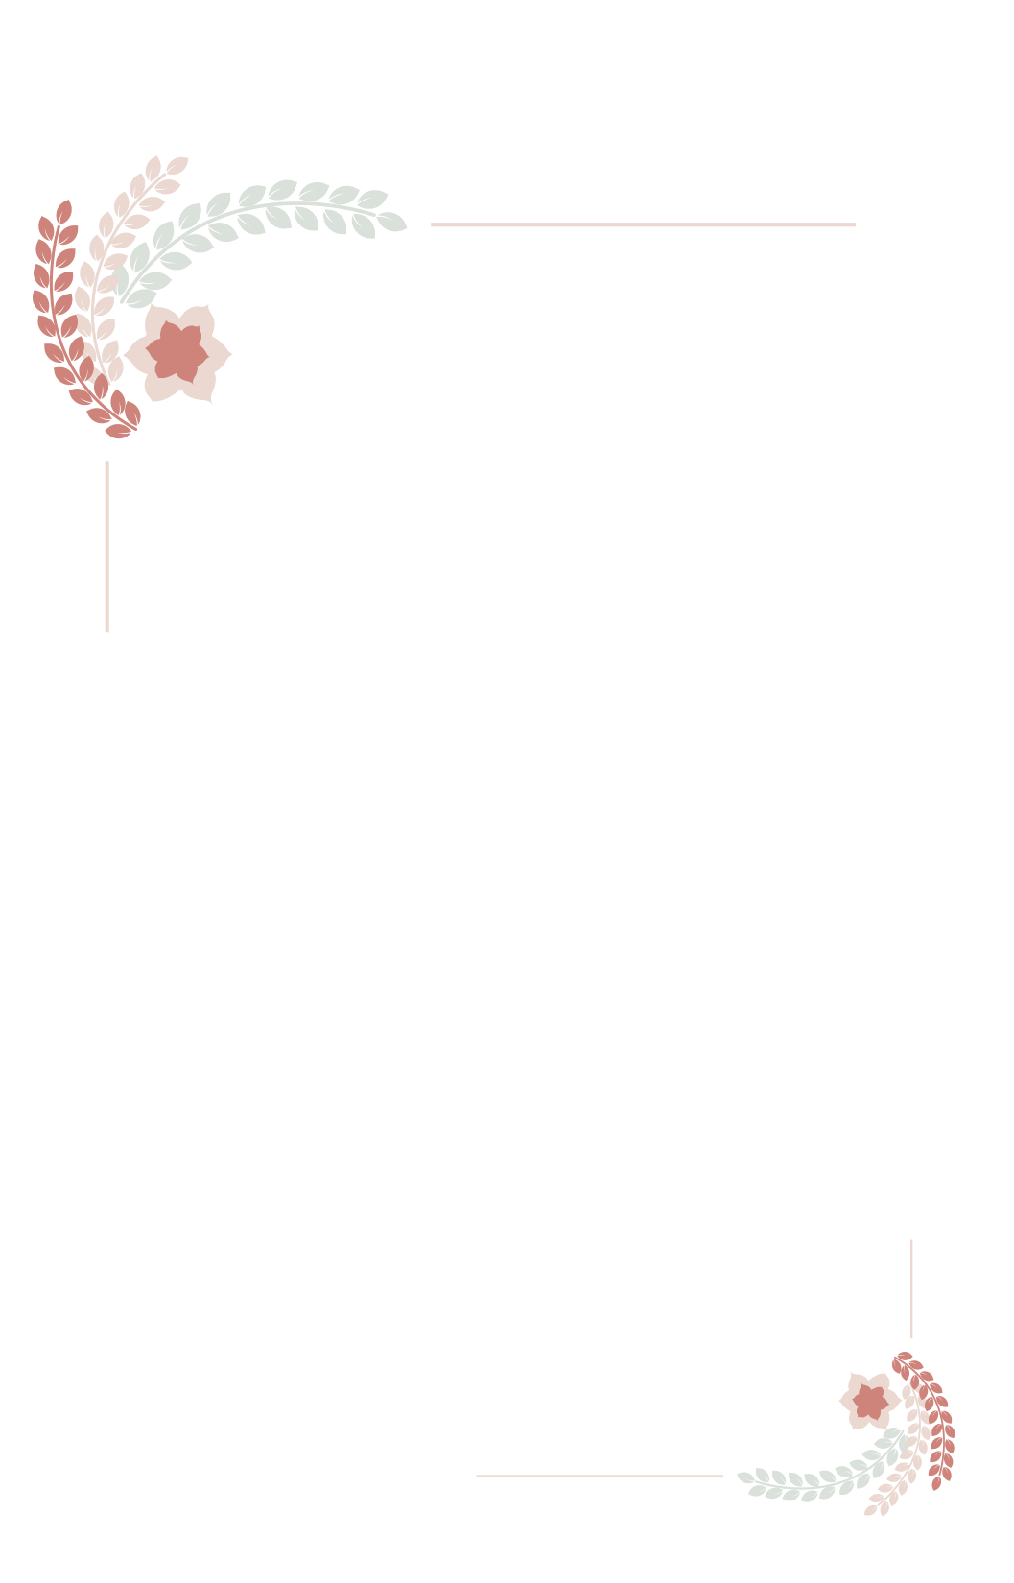

Town/City, County

###### **Formal invitation to follow**

Town/City, County

###### **Formal invitation to follow**

(Cut along dotted line (5x7 inches))