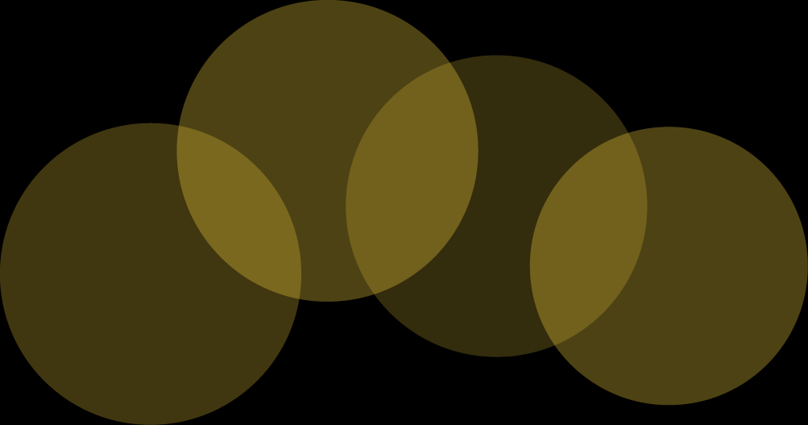

|  |
| --- |
| Happy Birthday! |
| Happy Birthday! |