[Reward]  [£000]  [Item]  [Location] | 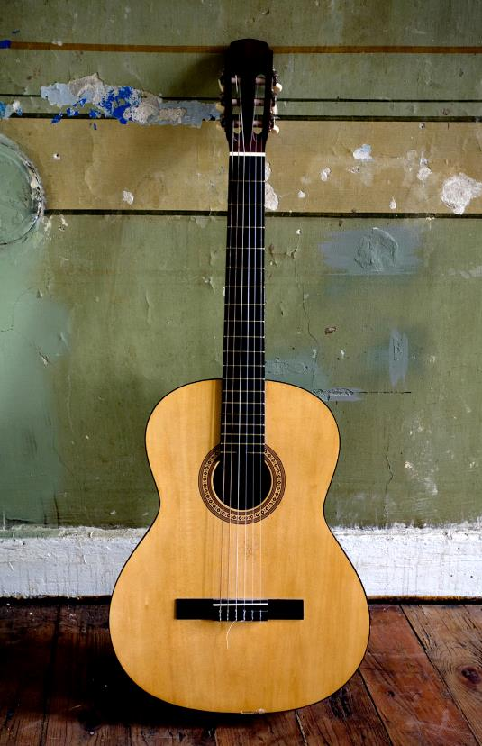
[Get started straight away]  [If you’re ready to write, just select a line of text and start typing to replace it with your own.] | [Look great every time]  [To replace the photo with your own, just delete it. Then, on the Insert tab, select Picture.]  [Need a heading? On the Home tab, in the Styles gallery, just tap on the heading style you want. For best results when selecting text to copy or edit, don’t include space to the right of the characters in your selection.]

