# Happy Holidays

**From Northwind Traders**

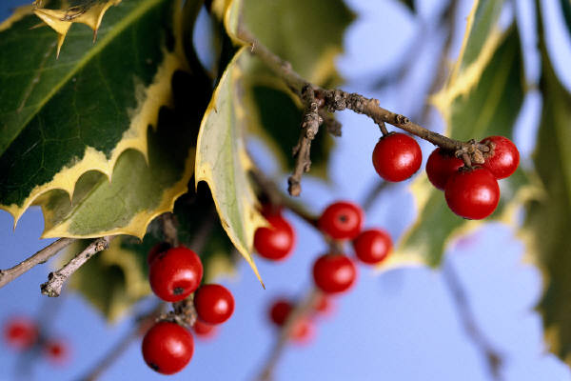

# Happy Holidays

**From Northwind Traders**









































